**INDEX**

|  |  |  |  |
| --- | --- | --- | --- |
| **Sr. No.** | **Topic** | **Page No.** | **Remarks** |
| 1. | **INTRODUCTION** | 4 |  |
| 2. | **OBJECTIVE OF THE PROJECT** | 5 |  |
| 2.1 | Benefits | 5 |  |
| 3 | **SYSTEM AND DESIGN ANALYSIS** | 6-8 |  |
| 3.1 | Preliminary Investigation | 8-9 |  |
| 3.2 | Planning phase | 10 |  |
| 3.3 | Fact finding techniques | 11-12 |  |
| 3.5 | Front end and Back end | 12 |  |
| 3.6 | Hardware and Software requirements | 12 |  |
| 3.7 | Gantt Chart | 13-14 |  |
| 3.8 | Class Diagram | 15-16 |  |
| 3.9 | Use Case Diagram | 17-18 |  |
| 4. | **RESEARCH AND DEVELOPMENT** | 19 |  |
| 4.1 | WEBSITE LAYOUT | 19 |  |
| 4.2 | Dropdown Menu | 21-26 |  |
| 4.3 | Newsletter | 26-27 |  |
| 4.4 | Form | 28-30 |  |
| 4.5 | Card | 30-35 |  |
| 4.6 | Footer | 36-37 |  |
| 4.7 | Modal | 37-39 |  |
| **5** | **RESERVATION FORM** | 40 |  |
| **6** | **ENQUIRY FORM** | 41 |  |
| **7** | **FEEDBACK FORM** | 44-44 |  |
| **8** | **CONTACT US** | 45-50 |  |
| **9** | **ONLINE BOOKING** | 51 |  |
| 9.1 | Bus Booking | 52-56 |  |
| 9.2 | Train Booking | 57-61 |  |
| 9.3 | Hotel Booking | 62-66 |  |
| 9.4 | Flight Booking | 67-71 |  |
| **10** | **ACCORDIAN AND FAQ** | 72-75 |  |
| **11** | **PARALLAX METHOD** | 76-77 |  |
| **12** | **TOUR AND PACKAGES** | 78-94 |  |
| **13** | **FONTAWESOME ICONS** | 95 |  |
| **14** | **CSS** | 96 |  |
| 14.1 | Colors | 96 |  |
| 14.2 | Media | 97-99 |  |
| 14.3 | Background | 99-101 |  |
| 14.4 | CSS Padding | 101-103 |  |
| **15** | **JAVA SCRIPT** | 104-106 |  |
| **16** | **BOOTSTRAP CDN** | 107-108 |  |
| **17.** | **SYSTEN DESIGN** | 109 |  |
| 17.1 | Payment gateway | 109-113 |  |
| **18** | **FUTURE SCOPE AND ENHANCEMENTS** | 114 |  |
| **19** | **SYSTEM TESTING** | 115-116 |  |
| **20** | **DATABASE CONNECTIVITY** | 117-119 |  |
| **21** | **CONCLUSION** | 120 |  |
| **22** | **BIBLIOGRAPHY** | 121 |  |

**1. INTRODUCTION**

**“THE CAMPING MONK”** is a tour and travel agency that has recently came into existence with most affordable and valuable packages that most of us can afford. They have their specification in mostly tour, camping and trekking ventures and moreover they have their own camp site in BILING top and have a team of professional trekkers and guides across areas. The website was built on HTML, CSS, JAVASCRIPT was used, PHP and MySQL at back end. Full coding was done on VS-code with multiple accordion, cards, parallax and was out images were used. Bootstrap 5 frameworks were used along with bootstrap properties and multiple style sheets were used.

The website is basically very much user friendly, anybody who wants to travel to Himachal and explore new touched and explored tribes can definitely come and give its opinion explore this new place. We have our connections with local and native people providing them their monthly income with more input and more tourist.

The tourist gets to explore the new places and the local people helps to generate tourism and money. It becomes a cycle and the pain pass continues to roll and thus making it much more compatible to other big vendors in the market. It has no annual fees or any hidden charges all are transparent and up to the mark.

**2. OBJECTIVE OF PROJECT**

The main objective of **Travel and Trekking**  is to provide the information about all the small to small things and most importantly make people aware that HIMACHAL PRADESH is one place where the is ample amount of resources, most unexplored place yet, the vision to see its beauty is almost beyond our imagination and thus promote tourism.

**2.1 Benefits**

Travelling and Trekking website provides user with a number of benefits, beyond the strict financial gains.

**Profile: -**User friendly profiles of websites are provided so that user feel homely and can easily download information without any problems.

**Feedback: -** User can also give feedback about their experience with our information if they like.

**Trainer: -** Trainer has access to upload the meaningful information and provide permission to user if the knowledge is free and extensible.

**3. System and Design Analysis (SAD)**

**Existing system:-**

All the work was done Manually.

In Manual Booking System Customer has to go to the Tours and Travel Agency.

Ask Inquiry for Travelling then Book ticket Finally Pay Payment & Collect Receipt.

Difficult To Maintain the Customer Details of Package and Payment

Receipt in Register.

They Register Tour Package in the notebook.

Add advertisement in Local newspaper or Local Market.

Use Travelling Facility For the Limited Area or Person.

**Proposed System:-**

To Create Web Based Application For our Organization.

To Provide Search Facility For Customer

. • To Generate Different Types of Reports.

To Provide the online Package Ticket Booking and online Payment Facility

**For Customer:-**

• To Provide package Details.

• Customer Can Cancel the Booking then Return 15% Less Deduct

• From the Amount.

• Services provided by Tour and travels System

**VIEW PACKAGE:-**

SEARCH PACKAGE

BOOKING

CANCEL BOOKING

ONLINE PAYMENT

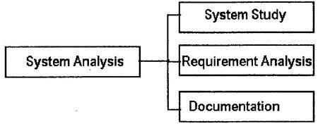

Fig.3.1 System Analsys

**System study**: The system study is information-oriented stage in which user; middlelevel and higher-level management have to face interviews.

**Interview**: The system analysis team conducts face-to-face interview with thestaff of organization.

**Questionnaire**: distribute questions (closed, open, probing types) to user and notetheir responses.

**Observation**: The actual position of men and machine are observed on-site.

Study of literatures, objective of organization, procedural manual etc is important tools for data collection.

**Requirement analysis**: The user expectation with new or candidate system is called userrequirement. The requirement can be qualitative and quantitative.

**Documentation**: The report of system study and requirement analysis is studied anddocumented. Designer team for system designing uses this document. If document does not contain appropriate information, design cannot be successful.

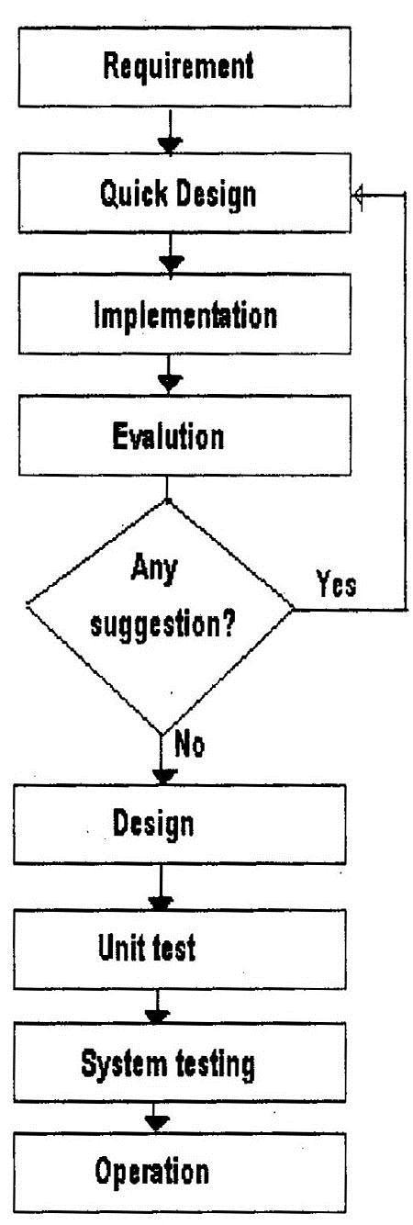

**3.1 Preliminary Investigation**

Preliminary Investigation basically refers to the collection of information that guides the management of an organization to evaluate the merits and demerits of the project request and make an informed judgment about the feasibility of the proposed system. This sort of investigation provides us with a through picture of the kind of software and hardware requirements which are most feasible for the system, plus the environment in which the entire project has to be installed and made operational.

**1)  Reviewing the documents provided by the organization**

They were quite effective in guiding us towards visualizing the features that were needed to be put together in the system and the required output which had to be generated once the system became functional.

These specifications provided to us by the organization showed how the new system should look like; it helped us in understanding the basic structure of the application which we were supposed to develop.

**2)  On site observation:**

Another technique utilized by us to gain information about the project was to visit the client site where the system had to be installed. Here a detailed system study was carried out, checking the existing system to replicate it with our system.  We also observed the activities of the system directly. During the on-site observation, we saw the office environment, work load of the system and users, method of work, and the facilities provided by the organization. This information helped us to understand how the system should operate. But after interviewing the persons, who is affected by the system, we got more details that further explain the project and shown whether assistance is merited economically, operationally and technically.

**3)  Conducting interviews:**

This method of investigation conducted by us involved questioning the concerned personnel to get the user’s (client) view about the system and the features they desired it to have. Some of the Questions put forward by our team were:

a)     The amount of data needed to be stored.

b)    The number of customers using the system and number of which the application needed to be installed.

c)     The issue of our application with existing system was widely discussed.

d)    The level of access given to the customer would depend on his department.

**3.2 PLANNING PHASE**

**FEASIBILITY STUDY:** The feasibility study is undertaken to determine the possibility of either improving the present system or developing a completely new system. It helps to obtain an overview of the problem and get an idea whether a feasible solution exists.

**Operational Feasibility Study:** The current system is manual. Thus processing large amount of data becomes a cumbersome activity. Reports that are generated are difficult to prepare manually and are also error prone. Operationally the Proposed system is feasibility because there are sufficient supports for project from management. It will be running smoother and faster that of existing system.

**Technical Feasibility Study:** Generally, new system brings new technology into an organization. The proposed system requires technology and equipment, which can be obtained. the operating system has the technical capacity to hold the data required to use the proposed system. The present equipment technology assures technical guarantee of accuracy, reliability and ease of access.

**Legal/Ethical Feasibility Study**: Determines whether the proposed system conflicts with legal requirements.

**Schedule Feasibility Study:** A project will fail if it takes too long to be completed before it is useful. Typically this means estimating how long the system will take to develop, and if it can be completed in given time period using some methods like payback period. Schedule feasibility is a measure of how reasonable the project timetable is. Given our technical expertise, are the project deadlines reasonable? Some projects are initiated with specific deadlines. You need to determine whether the deadlines are mandatory or desirable.

**Resource Feasibility Study:** This involves questions such as how much time is available to built the new system, when it can be built, whether it interferes with normal business operations, type and amount of resources required, dependencies.

**Cultural Feasibility Study**: In this stage, the project's alternatives are evaluated for their impact on the local and generated culture. For example, environmental factors need to be considered and these factors are to be well known. Further an enterprise's own culture can clash with the results of the project.

**3.4 Fact Finding Techniques**

We mainly used three fact finding techniques to find out for ourselves the correct information on the basis of which we will build the software. These fact finding techniques are extremely important because these are the facts on basis of which we can build the software that comprises of a friendly environment for the members work with. This is the reason why fact finding is an important activity grouped under the second phase “Requirement Analysis” of the Software Development life cycle.

The techniques which were used by us include:

• Interview and Questionnaire

• Document sampling

• Work site observation

**Interview & Questionnaire:** This is considered as one of the best fact finding technique. This include direct interaction with the customer. It is considered as the best technique, because it is the only way the user can reveal the details & fact about his past, present & expected working, requirements, technologies .These are the information which give us the description of the systems, we have to we have to implement our logic and our own ideas & make this description to turn to reality, to work as module which the user desire.

Questionnaire: Open-Ended Questions:

Q.1) How does your current process work?

Ans: All the information about employee are stored in the files similarly the customer details are stored in customer file.

Q.2) What are the main modules and attributes of your current System?

Ans: New register details, complaint details, payment, booking and report are the main modules etc. are the attributes.

Q.3) What are limitation of current process?

Ans: Functionality it’s a complex procedure, technically it’s difficult, lengthy and time consuming.

Close-Ended Questions:

Q.1) What is your Organization name?

Ans: THE CANMPING MONK

Q.2) Do the Organization have any branches?

Ans: No.

Q.3) On which platform your work manual report is prepared?

Ans: MS-Excel, MS-Word.

Q.4) Is your current system economically, functionally and technically feasible?

Ans: No.

Q.5) How many days it takes to submit my new proposed software?

Ans: 10-15 days

**3.5FRONT END and BACK END**

Front-end: HTML

CSS,

Bootstrap-5(Framework)

Back-end: MySQL

Php

JavaScript

**3.6 Hardware and Software Requirements**

Minimum Hardware Requirements:

Processor: Core i5-10500h

RAM: 8 GB RAM

Graphic card: GTX 1650 - 4GB

Hard Disk: 100MB Free Hard disk space

Monitor: IPS level 144hz super thin

Software Requirements

Operating System: Windows: 11 OS

Family Software : Java Database, MySQL, VS-Code

**3.7GANTTCHART** 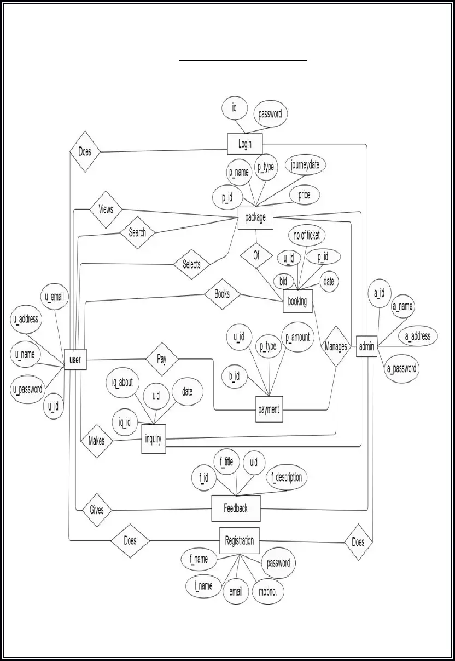

A Gantt chart is a project management tool that illustrates a project plan. It typically includes two sections: the left side outlines a list of tasks, while the right side has a timeline with schedule bars that visualize work. The Gantt chart can also include the start and end dates of tasks, milestones, dependencies between tasks, and assignees. To keep up with the demands of modern software development, roadmap tools like Jira Software include features like a collapsible task structure and resource management panels.

What is a Gantt chart used for?

Project managers use Gantt charts for three main reasons:

**Build and manage a comprehensive project**

Gantt charts visualize the building blocks of a project and organize it into smaller, more manageable tasks. The resulting small tasks are scheduled on the Gantt chart's timeline, along with dependencies between tasks, assignees, and milestones.

**Determine logistics and task dependencies**

Gantt charts can be employed to keep an eye on the logistics of a project. Task dependencies ensure that a new task can only start once another task is completed. If a task is delayed (it happens to the best of us), then dependent issues are automatically rescheduled. This can be especially useful when planning in a multi-team environment.

**Monitor progress of a project**

As teams log time towards issues in your plan, you can monitor the health of your projects and make adjustments as necessary. Your Gantt chart can include release dates, milestones, or other important metrics to track your project’s progress.

**The benefits of using a Gantt chart**

There are two main reasons why Gantt charts are loved throughout the project management world. They make it easier to create complicated plans, especially those that involve multiple teams and changing deadlines. Gantt charts help teams to plan work around deadlines and properly allocate resources.

Projects planners also use Gantt charts to maintain a bird’s eye view of projects. They depict, among other things, the relationship between the start and end dates of tasks, milestones, and dependent tasks. Modern Gantt chart programs such as Jira Software with Roadmaps and Advanced Roadmaps synthesize information and illustrate how choices impact deadlines

**3.8ClassDiagram**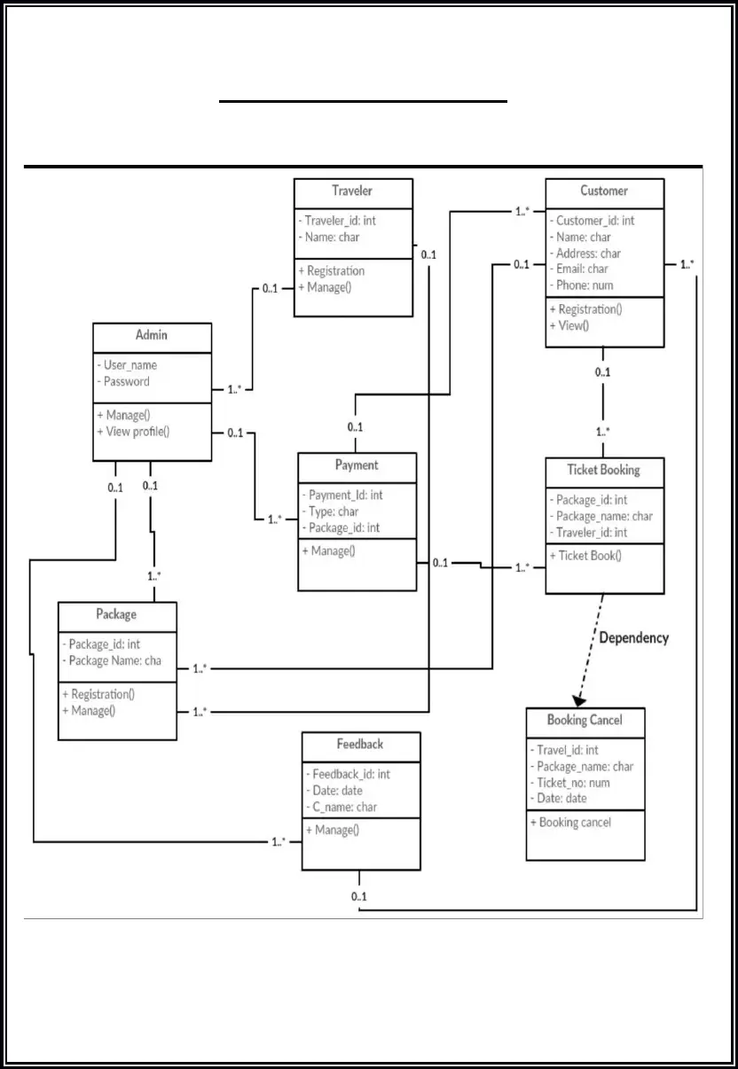

Class diagram is a static diagram. It represents the static view of an application. Class diagram is not only used for visualizing, describing, and documenting different aspects of a system but also for constructing executable code of the software application.

Class diagram describes the attributes and operations of a class and also the constraints imposed on the system. The class diagrams are widely used in the modeling of objectoriented systems because they are the only UML diagrams, which can be mapped directly with object-oriented languages

Purpose of Class Diagrams

The purpose of class diagram is to model the static view of an application. Class diagrams are the only diagrams which can be directly mapped with object-oriented languages and thus widely used at the time of construction.

UML diagrams like activity diagram, sequence diagram can only give the sequence flow of the application, however class diagram is a bit different. It is the most popular UML diagram in the coder community.

The purpose of the class diagram can be summarized as −

Analysis and design of the static view of an application.

Describe responsibilities of a system.

Base for component and deployment diagrams.

Forward and reverse engineering.

**3.9Use case Diagram**

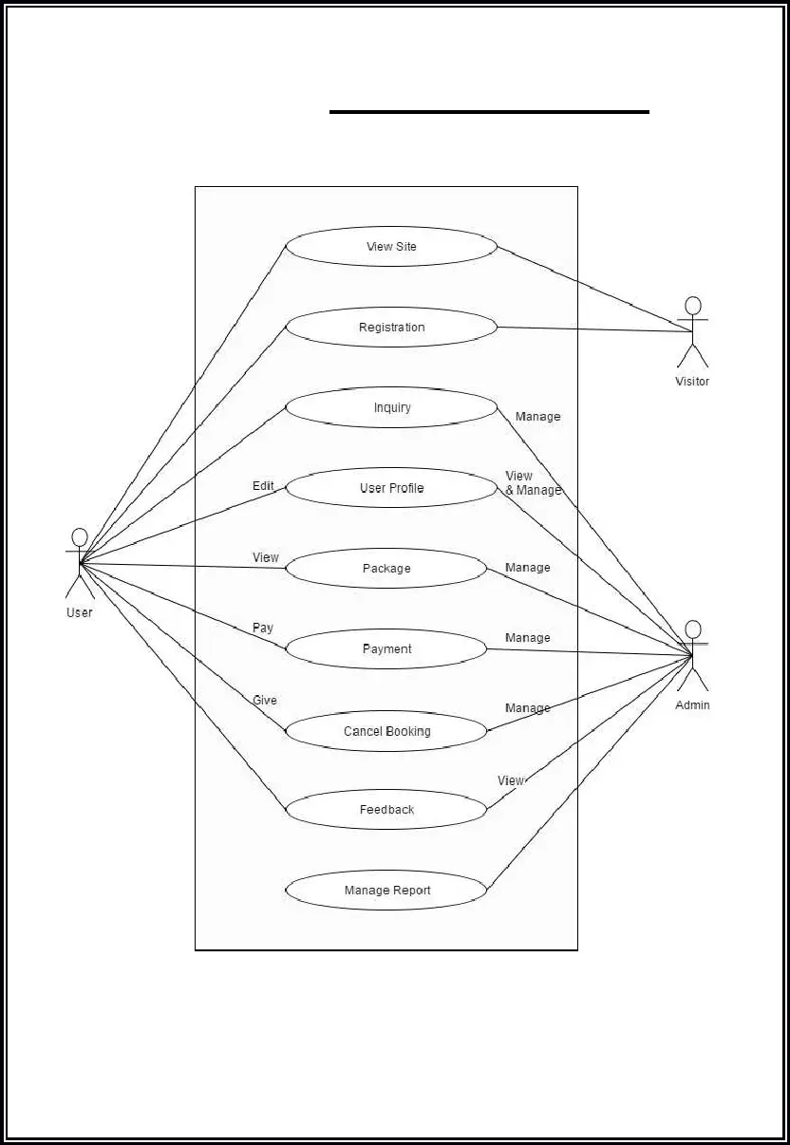

A use case diagram is used to represent the dynamic behavior of a system. It encapsulates the system's functionality by incorporating use cases, actors, and their relationships. It models the tasks, services, and functions required by a system/subsystem of an application. It depicts the high-level functionality of a system and also tells how the user handles a system.

Purpose of Use Case Diagrams

The main purpose of a use case diagram is to portray the dynamic aspect of a system. It accumulates the system's requirement, which includes both internal as well as external influences. It invokes persons, use cases, and several things that invoke the actors and elements accountable for the implementation of use case diagrams. It represents how an entity from the external environment can interact with a part of the system.

Following are the purposes of a use case diagram given below:

It gathers the system's needs.

It depicts the external view of the system.

It recognizes the internal as well as external factors that influence the system.

It represents the interaction between the actors.

**4. REASEARCH AND DEVELOPMENT**

The complete R&D was done that was done from various websites and what all things are needed in the website.

**4.1 WEBSITE LAYOUT**

<!DOCTYPE html>

<html lang="en">

    <head>

        <meta charset="utf-8">

        <meta name="viewport" content="width=device-width, initial-scale=1.0">

        <link href="https://cdn.jsdelivr.net/npm/bootstrap@5.0.1/dist/css/bootstrap.min.css"

        rel="stylesheet" crossorigin="anonymous"/>

        <script src="https://kit.fontawesome.com/32702421dd.js" crossorigin="anonymous"></script>

        <link rel="stylesheet" href="https://cdnjs.cloudflare.com/ajax/libs/ionicons/2.0.1/css/ionicons.min.css">

        <link rel="stylesheet" href="style.css" />

        <title>THE CAMPING MONK</title>

    </head>

    <body

**4.2DROP DOWN MENU:-** A drop-down menu is a list of options that is revealed only when a user interacts with the menu, either by clicking it or hovering over it with their cursor. The menu options then descend vertically and disappear again once the user disengages from the menu.

Since dropdown menus allow you to place more content and links on a page without cluttering it, they’re commonly used on websites and web applications to hide items that users might not need to see after the initial page load, but still might want to use.

Common use cases for HTML dropdowns include:

[**navigation menus**](https://blog.hubspot.com/website/main-website-navigation-ht) that contain links to other pages on a website

[**web forms**](https://blog.hubspot.com/marketing/web-forms) (including mobile-first [**Bootstrap forms**](https://blog.hubspot.com/website/bootstrap-form-css)) that list options from which the user may choose one

site searches for listing sorting or filtering options for a query

as an alternative to [**radio buttons**](https://blog.hubspot.com/website/html-radio-button) that saves page space.

Dropdown menus contain several moving parts that all need to work together for a seamless user experience. If your dropdown doesn’t work as expected, users can become easily annoyed. That’s why it’s so important to implement them correctly in HTML.

**<!--navbar-->**

          <nav class="navbar navbar-expand-lg navbar-light bg-light">

        <style>

        .navbar-collapse {

            flex-basis: 0;

            flex-grow: 0;

            // For always expanded or extra full navbars, ensure content aligns itself

            // properly vertically. Can be easily overridden with flex utilities.

          }

          .navbar>.container, .navbar>.container-fluid, .navbar>.container-lg, .navbar>.container-md, .navbar>.container-sm, .navbar>.container-xl, .navbar>.container-xxl {

    display: flex;

    flex-wrap: inherit;

    align-items: center;

    justify-content: space-evenly;

}

        </style>

        <div class="container-fluid" >

            <img class="img size=100px bg-transparent" src="/images/tmc logo.png"  alt="">

          <button class="navbar-toggler" type="button" data-bs-toggle="collapse" data-bs-target="#navbarSupportedContent" aria-controls="navbarSupportedContent" aria-expanded="false" aria-label="Toggle navigation">

            <span class="navbar-toggler-icon"></span>

          </button>

          <div class="collapse navbar-collapse" id="navbarSupportedContent">

                <ul class="navbar-nav me-auto mb-2 mb-lg-0">

              <li class="nav-item">

                <a class="nav-link active" aria-current="page" href="//127.0.0.1:5500/index.html#"><i class="fa-solid fa-house-chimney"></i>Home</a>

              </li>

              <li class="nav-item">

                <a class="nav-link" href="RESERVATION.html"><i class="fa-solid fa-mountain-sun"></i>Camping Reservation</a>

              </li>

          <li class="nav-item dropdown">

            <a class="nav-link dropdown-toggle" href="#" id="navbarDropdown" role="button" data-bs-toggle="dropdown" aria-expanded="false">

              <i class="fa-solid fa-arrow-down-short-wide"></i>Online bookings

            </a>

            <ul class="dropdown-menu" aria-labelledby="navbarDropdown">

            <li><a class="dropdown-item" href="bus.html"><i class="fa-solid fa-bus p-2" ></i>Bus Booking</i></a></li>

            <li><a class="dropdown-item" href="train.html"><i class="fa-solid fa-train-subway p-2"></i>Train Booking</a></li>

            <li><a class="dropdown-item" href="flight.html"><i class="fa-solid fa-plane-departure p-2"></i>Flights Booking</a></li>

            <li><a class="dropdown-item" href="hotels.html"><i class="fa-solid fa-hotel p-2"></i>Hotels Booking</a></li>

          </ul>

        </li>

        <li class="nav-item dropdown">

          <a class="nav-link dropdown-toggle" href="#" id="navbarDropdown" role="button" data-bs-toggle="dropdown" aria-expanded="false">

              <i class="fa-solid fa-globe"></i>Tour and packages

          </a>

          <ul class="dropdown-menu" aria-labelledby="navbarDropdown">

          <li><a class="dropdown-item" href="leh itenary.html"><i class="fa-solid fa-suitcase"></i>Leh-ladakh package</i></a></li>

          <li><a class="dropdown-item" href="manali package.html"><i class="fa-solid fa-suitcase"></i>Manali package</a></li>

          <li><a class="dropdown-item" href="spiti kaza.html"><i class="fa-solid fa-suitcase"></i>Spiti-Kaza packages</a></li>

          <li><a class="dropdown-item" href="dharamshala .html"><i class="fa-solid fa-suitcase"></i>Dharamshala package</a></li>

          <li><a class="dropdown-item" href="killar.html"><i class="fa-solid fa-suitcase"></i>Killar-kishtawar packages </i></a></li>

          <li><a class="dropdown-item" href="tirthan.html"><i class="fa-solid fa-suitcase"></i>Tirthan package</a></li>

          <li><a class="dropdown-item" href="chitkul .html"><i class="fa-solid fa-suitcase"></i>Kinnaur-Chitkul packages</a></li>

          <li><a class="dropdown-item" href="shimla .html"><i class="fa-solid fa-suitcase"></i>Shimla-kasauli packages</a></li>

          <li><a class="dropdown-item" href="dalhousie.html"><i class="fa-solid fa-suitcase"></i>Dalhousie-chamba packages</a></li>

          <li><a class="dropdown-item" href="mandi.html"><i class="fa-solid fa-suitcase"></i>Barot-Mandi packages</a></li>

        </ul>

      </li>

              <li class="nav-item dropdown">

                <a class="nav-link dropdown-toggle" href="#" id="navbarDropdown" role="button" data-bs-toggle="dropdown" aria-expanded="false">

            <i class="fa-solid fa-bars"></i>More-Options

                </a>

                <ul class="dropdown-menu" aria-labelledby="navbarDropdown">

                  <li><a class="dropdown-item" href="contact.html"><i class="fa-solid fa-people-arrows-left-right p-2""></i>Contact-us</a></li>

                  <li><a class="dropdown-item" href="enquiry.html"><i class="fa-solid fa-magnifying-glass p-2""></i>Enquiry</a></li>

                  <li><a class="dropdown-item" href="feedback.html"><i class="fa-solid fa-comments p-2""></i>Feedback</a></li>

                </ul>

              </li>

            </ul>

          </div>

        </div>

      </nav>

      <div class="row g-4">

      <div class="card bg-dark text-white text-center">

        <video class="card-img" autoplay="true" loop="true" muted="" controls="true">

            <source src="/video/trek.mp4" type="video/mp4">

           </video>

        <div class="card-img-overlay">

                <div class="position-absolute top-50 start-50 translate-middle" style="background-color: #00000040;">

                            <h1 class="display-1 card-title"><i><b>THE CAMPING MONK</i></b></h1>

        <div class="clearfix">

            <form class="btn btn-danger float-left" action="contact.html" method="get" target="_blank">

                <button type="submit" class="btn btn-danger float-left" >CONTACT US</button>

                </form>

                <form class="btn btn-danger float-right" action="loginform.html" method="get" target="_blank">

            <button type="submit" class="btn btn-danger float-right">LOGIN FORM</button>

                </form>

          </div>

        </div>

          </div>

      </div>

      </div>

**<!--navbar END-->**

**<!--showcase-->**

        <section class="bg-light text-dark p-5 p-lg-0 text-center text-sm-start">

                    <div class="row g-4">

            <!--flexbox for 1 part upper-->

            <div class="d-sm-flex align-items-center justify-content-between">

                <div class="p-5">

                    <h1>exploring and trekking <span class="text-danger"> VENTURES</span></h1>

                    <p class="lead">THE CAMPING MONK is tour and travel company which provide best tour and camping services in HIMACHAL PRADESH.

                    We provide reservation for hotels, buses , trains , flights and all tourist places.

                    Contact us for the best packages and  discounts.

                    </p>

                    <button type="button" class="btn btn-danger" data-bs-toggle="modal" data-bs-target="#exampleModal"> join us</button>

                    </div>

                <div>

                    <img class="img-fluid w-60 d-none d-sm-block" src="/images/logo.png" alt="">

                </div>

            </div>

            </div>

        </section>

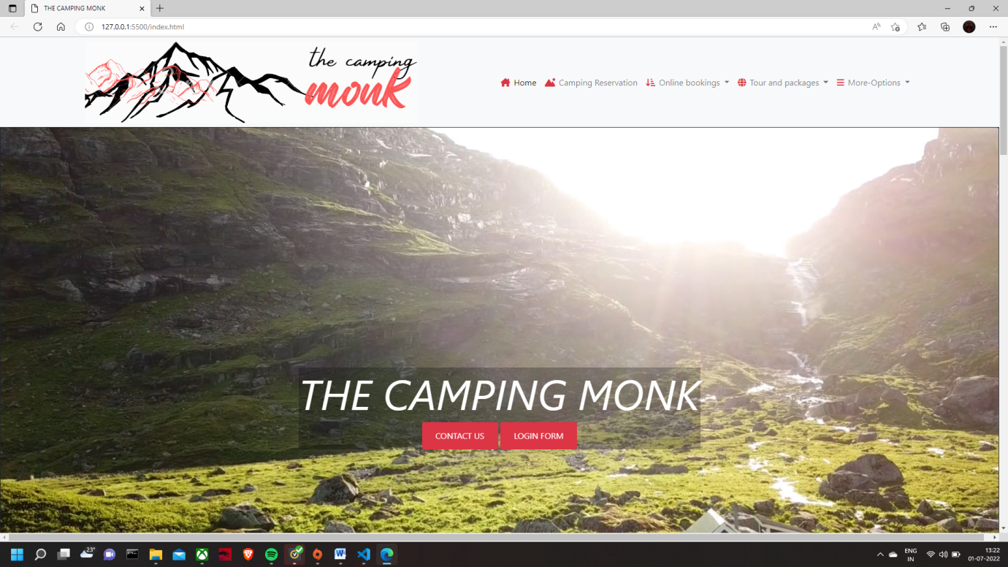

**4.3NEWSLETTER**:- A newsletter is a tool used by businesses and organizations to share relevant and valuable information with their network of customers, prospects and subscribers. Newsletters give you direct access to your audience’s inbox, allowing you to share engaging content, promote sales and drive traffic to your website.

**PLATFORM FOR NEWSLETTERS:-**

HubSpot

Mailchimp

AWeber

Sendin Blue

Klaviy

**<!--NEWSLETTER-->**

    <div id="parallax-world-of-ugg">

    <section>

        <div class="parallax-ten text-center text-light text-uppercase">

            <section class="bg-transparent text-dark border p-5 m-5 border-1  border-danger m-1 ">

                <div="d-md-flex  justify-content-between  align-items-center p-3">

                    <h3 class="mb-2 mb-md-3 ">Sign up to get more updates</h3>

                    <div class="input-group news-input m-1 ">

                        <input type="text" class="form-control" placeholder="Enter e-mail address" aria-label="Recipient's username" aria-describedby="button-addon2sss">

                        <button class="btn btn-danger btn-md" type="button" >Sign-up</button>

                    </div>

                </div>

            </section>

        </div>

        </section>

</div>

**<!—NEWSLETTER END-->**

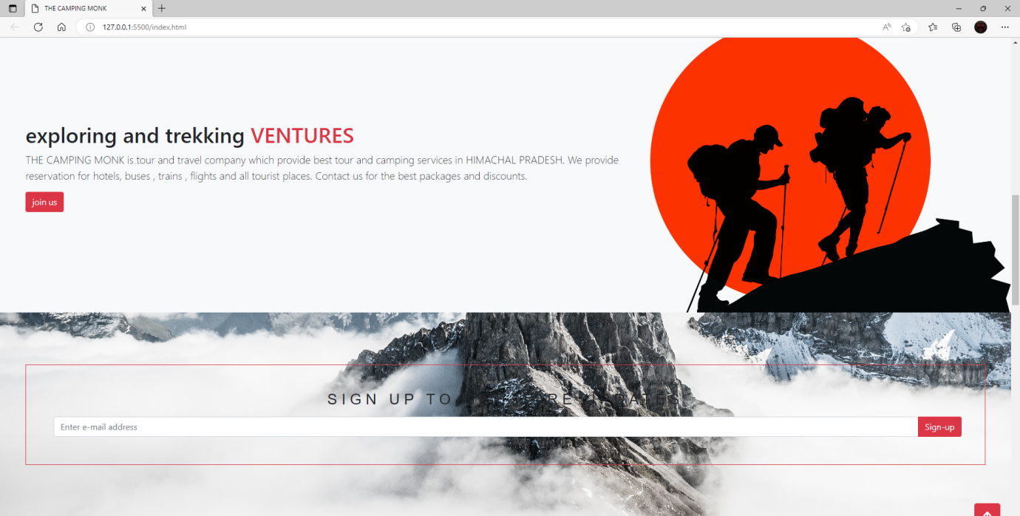

**4.4 FORM:-** An **HTML form** is *a section of a document* which contains controls such as text fields, password fields, checkboxes, radio buttons, submit button, menus etc.

An HTML form facilitates the user to enter data that is to be sent to the server for processing such as name, email address, password, phone number, etc.

|  |  |
| --- | --- |
| <form> | It defines an HTML form to enter inputs by the used side. |
| <input> | It defines an input control. |
| <textarea> | It defines a multi-line input control. |
| <label> | It defines a label for an input element. |
| <fieldset> | It groups the related element in a form. |
| <legend> | It defines a caption for a <fieldset> element. |
| <select> | It defines a drop-down list. |
| <optgroup> | It defines a group of related options in a drop-down list. |
| <option> | It defines an option in a drop-down list. |
| <button> | It defines a clickable button. |

**LOGIN FORM**

  </style>

  </head>

  <body>

    <div class="background">

      <div class="shape"></div>

    </div>

    <form>

      <h3>Login Here</h3>

      <label for="username">Username</label>

      <input type="text" placeholder="Email or Phone" id="username" />

      <label for="password">Password</label>

      <input type="password" placeholder="Password" id="password" />

      <button>Log In</button>

      <div class="social">

        <div class="go"><i class="fab fa-google"></i> Google</div>

        <div class="fb"><i class="fab fa-facebook"></i> Facebook</div>

      </div>

    </form>

  </body>

</html>

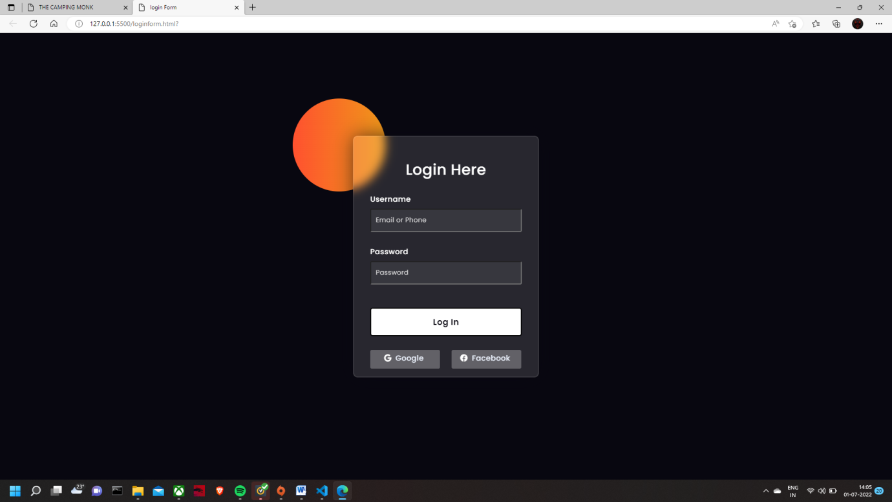

**4.5 CARD:-** A **card** is a flexible and extensible content container. It includes options for headers and footers, a wide variety of content, contextual background colors, and powerful display options. If you’re familiar with Bootstrap 3, cards replace our old panels, wells, and thumbnails. Similar functionality to those components is available as modifier classes for cards.

Cards are built with as little markup and styles as possible, but still manage to deliver a ton of control and customization. Built with flexbox, they offer easy alignment and mix well with other Bootstrap components. They have no margin by default, so use [spacing utilities](https://getbootstrap.com/docs/5.0/utilities/spacing/) as needed.

Below is an example of a basic card with mixed content and a fixed width. Cards have no fixed width to start, so they’ll naturally fill the full width of its parent element. This is easily customized with our various [sizing options](https://getbootstrap.com/docs/5.0/components/card/#sizing).

**Titles, text, and links**

Card titles are used by adding .card-title to a <h*> tag. In the same way, links are added and placed next to each other by adding .card-link to an <a> tag.

Subtitles are used by adding a .card-subtitle to a <h*> tag. If the .card-title and the .card-subtitle items are placed in a .card-body item, the card title and subtitle are aligned nicely.

**Images**

.card-img-top places an image to the top of the card. With .card-text, text can be added to the card. Text within .card-text can also be styled with the standard HTML tags.

 <!--BOXES-->

            <div id="parallax-world-of-ugg">

                <div class="parallax-nine text-center text-light text-uppercase">

        <section class ="p-5 m-1">

            <div class="row text-center g-4 ">

                <div class="col-sm-4 position-relative ">

                                        <div class="card-img-overlays"  >

                     <div class="p-3 m-4" style="background-color: #00000040;">

                        <h3 class="mb-4" class="text-light"> TREKKING </h3>

                        <p style="font-size:16px" class="text-light"> <b><i>We the camping monk have a team of professional and local guides who can make you people explore new and unotouched valleys and places that exists here and hardly tourist know about that unexpored adventures.</i></b></p>

                        <a href="explore.html" class="btn btn-primary">EXPLORE</a>

                    </div>

                </div>

                </div>

            <!--IMAGE1-->

                <div class="col-sm-4 position-relative">

                           <div class="card-img-overlays" >

                    <div class="p-4 m-4" style="background-color: #00000040;">

                        <h3 class=" mb-2" class="text-light"> PARAGLIDING </h3>

                        <p style="font-size:16px"  class="text-light"><b><i>Paragliding is an adventure where two people fly on a single paragliding glider. A super adventurous aero-sport activity which needs a lot of training and experience to operate para-glider safely.</i></b></p>

                        <a href="experience.html" class="btn btn-primary">EXPERIENCE</a>

                    </div>

                </div>

                </div>

                <div class="col-sm-4 position-relative ">

                        <div class="card-img-overlays" >

                    <div class="p-4 m-4" style="background-color: #00000040;">

                        <h3 class="mb-4" class="text-light"> CAMPING </h3>

                        <p style="font-size:16px" class="text-light"> <b><i>Camping is an outdoor activity involving overnight stays away from home,either without shelter or using basic shelter such as a tent .To see the majestic views in front of your eyes.</i></b>

</p>

                        <a href="engage.html" class="btn btn-primary">ENGAGE</a>

                    </div>

                    </div>

                </div>

            </div>

                </section>

           </div>

        </div>

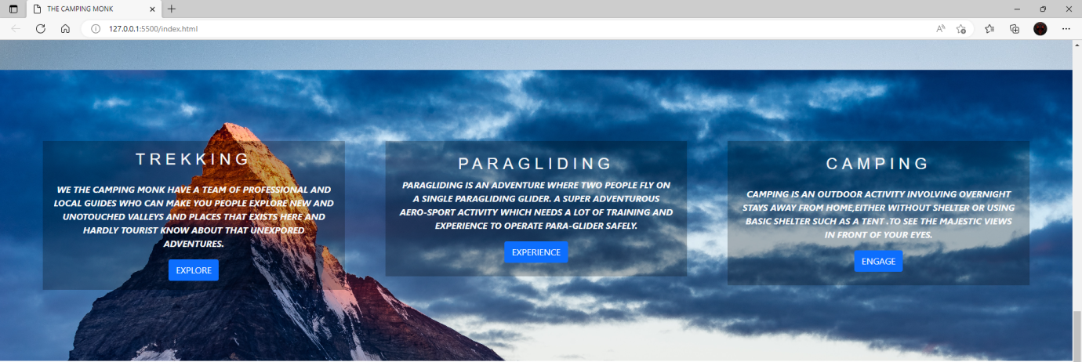

**<!--ABOUT TREKKING-->**

              <div class=" text-center text-dark text-uppercase">

        <section class="p-5">

                <div class="row g-4">

                    <div class="col-md-5">

                        <img class="img-fluid  d-none d-lg-block" src="/images/tcm1.png" alt="">

                    </div>

                    <div class="col-md-7">

                        <h2 class="text-center text-danger mb-4">ABOUT TREKKING AND CAMPING</h2>

                        <p>Triund Trek, Hampta Pass Trek, Bhrigu Lake Trek, Indrahar Pass Trek, Kheerganga Trek, Pin Parvati Trek, Tosh Valley Trek, Kareri Lake Trek, Prashar Lake Trek, Beas Kund Trek, Bhaba Pass Trek, Chanderkhani Pass Trek and many more adventurous treks.

                        Trekking in Himachal generally calls for people of all age groups and levels of expertise with good physical fitness, since the state is home to easy to difficult treks with lenient to steep terrains. While Hampta Pass Trek, Bhrigu Lake Trek, Beas Kund Trek, and Kheerganga Trek offer easy to moderate treks that even first-timers can opt, Indrahar Pass Trek, Pin Parvati Trek, Chanderkhani Pass Trek, and Bhaba Pass Trek offer moderate to difficult treks that make for the most thrilling experiences.

                        The exhilarating trekking places in Himachal manifest diverse landscapes and let you soak in unparalleled views of world-famous breathtaking summits, offering you the chance to not only satisfy your adrenaline rush, but also to achieve a wonderful treat for your eyes in return of your efforts</p>

                                        </div>

                                    </div>

            </section>

    </div

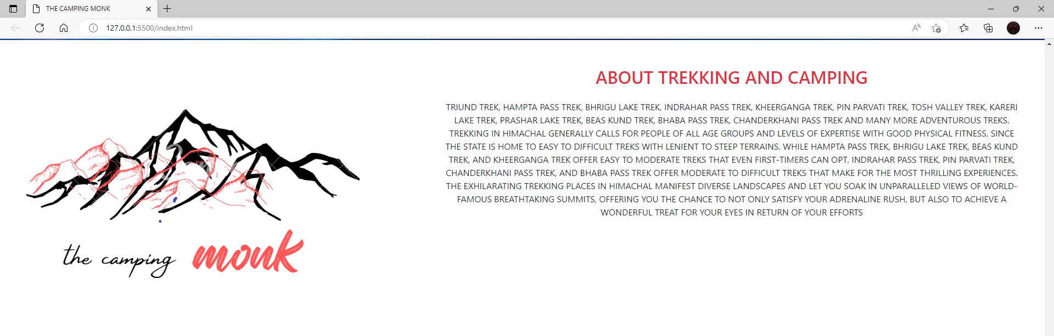

**<!--CONTACT US AND MAP-->**

                <div id="parallax-world-of-ugg">

                    <div class="parallax-four text-center text-light text-uppercase">

            <section class="p-5">

                <div class="row g-4">

                    <div class="col-md-4">

                        <h2 class="text-center mb-4">CONTACT-INFO</h2>

                        <ul class="list-group list-group-flush lead">

                            <li class="list-group-item">

                                <span class="fw-bold">OFFICE LOCATION:</span>V.P.O Malan ,Teh&Dist Kangra HIMACHAL PRADESH,INDIA

                            </li>

                            <li class="list-group-item">

                                <span class="fw-bold">SITE LOCATION:</span>The paragliding runway point biling

                            </li>

                            <li class="list-group-item">

                                <span class="fw-bold">PHONE NUMBER:</span> +91 8968753377, +91 7834053577

                            </li>

                            <li class="list-group-item">

                                <span class="fw-bold">NAME:</span>GAURAV RANA(@the camping monk)

                            </li>

                            <li class="list-group-item">

                                <span class="fw-bold">e-mail:</span>contact@thecampingmonk.com

                            </li>

                        </ul>

                    </div>

                    <div class="col-md">

<iframe src="https://www.google.com/maps/embed?pb=!1m18!1m12!1m3!1d27049.454732353228!2d76.72770546721856!3d32.06433011531508!2m3!1f0!2f0!3f0!3m2!1i1024!2i768!4f13.1!3m3!1m2!1s0x3904bed81dfeae35%3A0x16f003fd3cac51a1!2sBiling%2C%20Himachal%20Pradesh!5e0!3m2!1sen!2sin!4v1656575667829!5m2!1sen!2sin" width="600" height="450" style="border:0;" allowfullscreen="" loading="lazy" referrerpolicy="no-referrer-when-downgrade"></iframe>

                    </div>

                </div>

            </section>

            </div>

        </div>

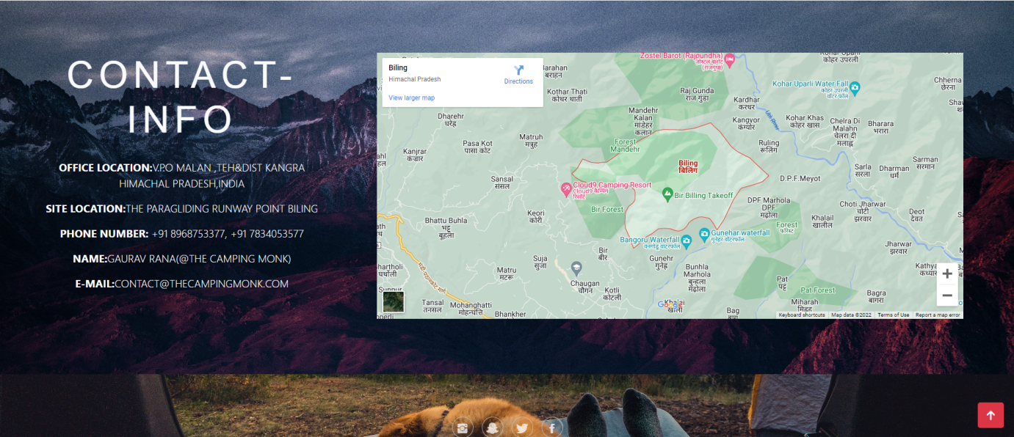

**4.6 FOOTER:-** Footers are a great way to organize a lot of site navigation and information at the end of a page. This is where the user will look once they have finished scrolling through the current page or are looking for additional information about your website.

Sticky Footer :-A sticky footer always stays on the bottom of the page regardless of how little content is on the page. However, this footer will be pushed down if there is a lot of content, so it is different from a fixed footer. Add the following code to your CSS file.

        <!--FOOTER-->

            <div id="parallax-world-of-ugg">

                <div class="parallax-nineteen text-center text-light text-uppercase">

    <div class="footer-basic">

                <footer>

            <div class="social"><a href="https://www.instagram.com/accounts/signup"><i class="icon ion-social-instagram"></i></a><a href="https://www.snapchat.com/add/login">

                <i class="icon ion-social-snapchat"></i></a><a href="https://twitter.com/login"><i class="icon ion-social-twitter"></i></a><a href="https://www.facebook.com/login.php

                "><i class="icon ion-social-facebook"></i></a></div>

            <ul class="list-inline">

                <li class="list-inline-item"><a href="#">Home</a></li>

                <li class="list-inline-item"><a href="#">Services</a></li>

                <li class="list-inline-item"><a href="#">About</a></li>

                <li class="list-inline-item"><a href="#">Terms</a></li>

                <li class="list-inline-item"><a href="#">Privacy Policy</a></li>

                <li class="list-inline-item"><a href="ax.html">FAQ</a></li>

            </ul>

            <p class="copyright">thecampingmonk © 2022</p>

        </footer>

    </div>

    </div>

            </div>

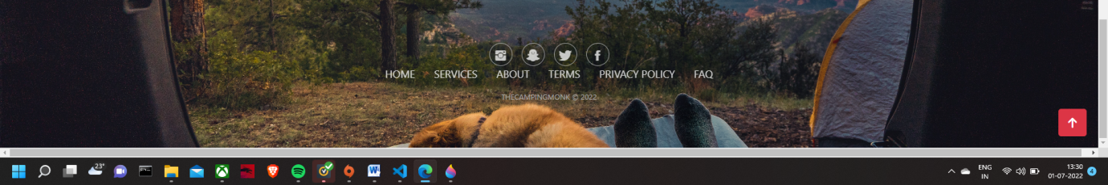

**4.7 MODAL**:- Modals are built with HTML, CSS, and JavaScript. They're positioned over everything else in the document and remove scroll from the <body> so that modal content scrolls instead. Clicking on the modal “backdrop” will automatically close the modal. Bootstrap only supports one modal window at a time.

Modals are built with HTML, CSS, and JavaScript. They’re positioned over everything else in the document and remove scroll from the <body> so that modal content scrolls instead.

Clicking on the modal “backdrop” will automatically close the modal.

Bootstrap only supports one modal window at a time. Nested modals aren’t supported as we believe them to be poor user experiences.

Modals use position: fixed, which can sometimes be a bit particular about its rendering. Whenever possible, place your modal HTML in a top-level position to avoid potential interference from other elements. You’ll likely run into issues when nesting a .modal within another fixed element.

Once again, due to position: fixed, there are some caveats with using modals on mobile devices. [See our browser support docs](https://getbootstrap.com/docs/4.0/getting-started/browsers-devices/#modals-and-dropdowns-on-mobile) for details.

<!-- Modal -->

<div class="modal fade" id="exampleModal" tabindex="-1" aria-labelledby="exampleModalLabel" aria-hidden="true">

  <div class="modal-dialog">

    <div class="modal-content">

           <div class="modal-body">

                            <p class="lead">Fill form details and we will get back to you</p>

                            <form>

                                <div class="mb-3">

                                    <label for="firt-name" class="col-from-label">FIRST NAME:</label>

                                    <input type="text" class="form-control" id="first-name"/>

                                </div>

                                <div class="mb-3">

                                    <label for="last-name" class="col-from-label">LAST NAME</label>

                                    <input type="text" class="form-control" id="last-name"/>

                                </div>

                                <div class="mb-3">

                                    <label for="phone-number" class="col-from-label">PHONE NUMBER</label>

                                    <input type="text" class="form-control" id="phone-number"/>

                                </div>

                                <div class="mb-3">

                                    <label for="e-mail" class="col-from-label">E-mail</label>

                                    <input type="text" class="form-control" id="e-mail"/>

                                </div>

                                                           <div class="modal-footer">

                                    <button type="button" class="btn btn-secondary" data-bs-dismiss="modal">Close</button>

                                    <button type="button" class="btn btn-primary">SUBMIT</button>

                                </div>

                            </form>

                        </div>

    </div>

  </div>

</div>

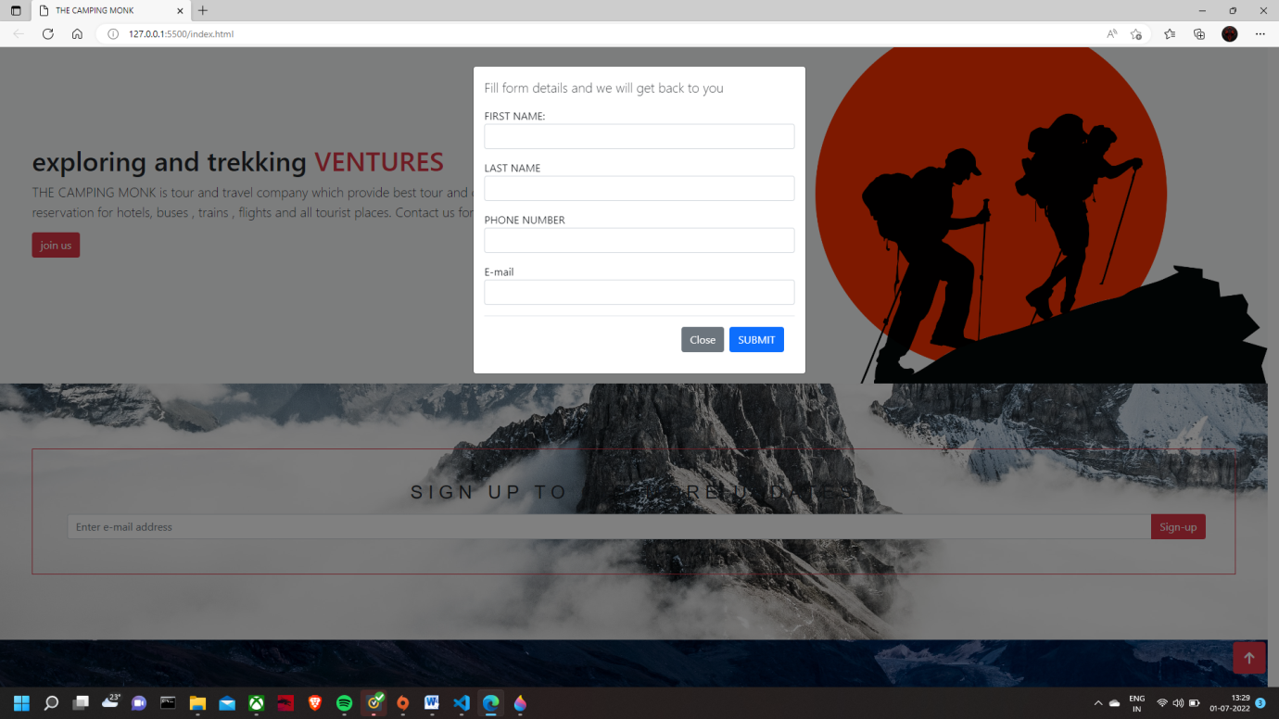

.

**5. RESERVATION FORM**

A reservation form is a document that records the reservation information of a client when booking accommodations or services in a hotel, a flight, restaurant, or other.

A reservation includes the guest’s personal information such as name, email address, phone number – as well as specific information applicable to the type of reservation, which can be the name of the company, the number of attendees, the date and time of arrival and departure, and special requirements

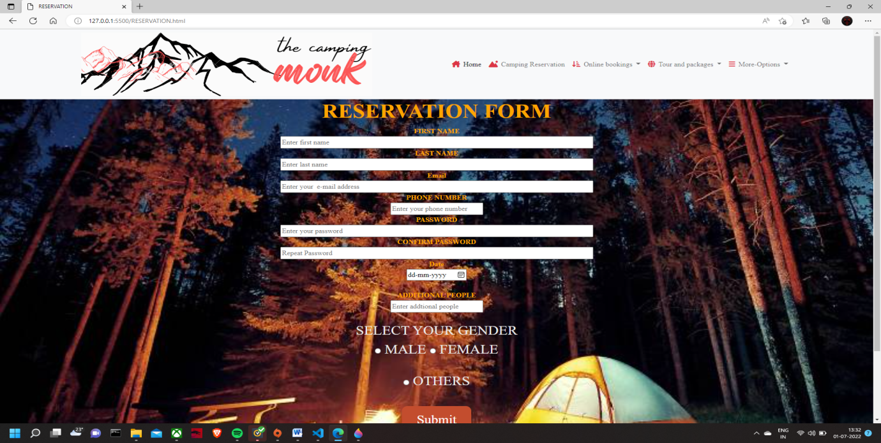

**6.ENQUIRY FORM**

An enquiry form is a form business, educational institutions, and NGOs can use to provide their customers/ students/ donors with a means of asking questions about the activity of the organization at hand.

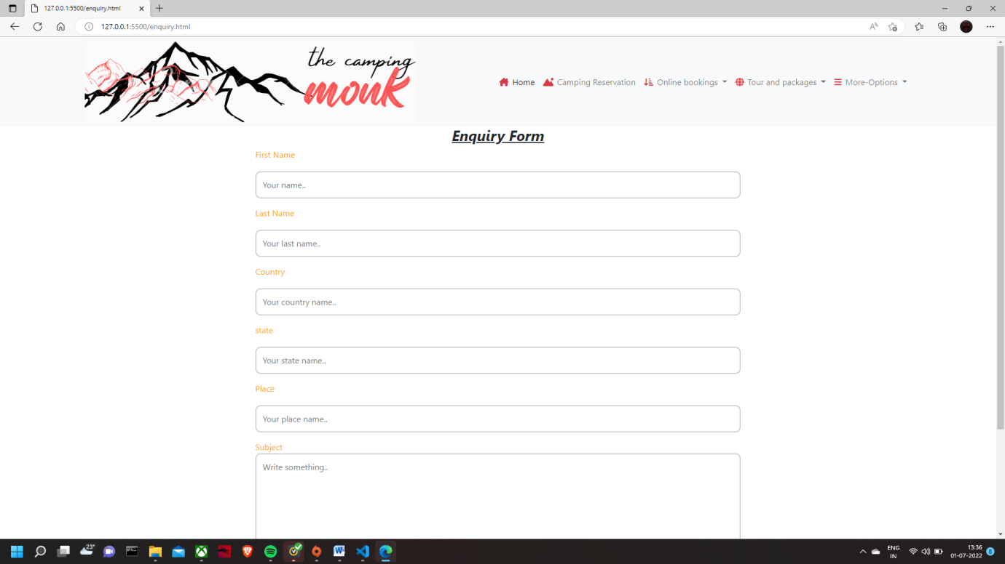

**7.FEEDBACK FORM**

A feedback form is a way to collect opinions about your company’s service. The goal is to gain a better understanding of the overall customer experience so you can identify areas for improvement.

Customer satisfaction survey

A satisfaction survey enables business owners to understand why a customer was or was not happy with their purchase and overall experience. Questions encourage the customer to tell the business how they were treated, what product or services were missing, what went wrong, what could be better and more.

User experience questionnaire

A user experience questionnaire is often used by software companies that want to ensure their product is simple and effective. Unlike a survey about a product or service, a questionnaire will focus far more on the features, how they work, what՚s missing and what could be improved.

<div class="container-fluid">

  <div class="row justify-content-center">

  <div class="col-md-6 align-self-center">

<h2><center>FEEDBACK FORM</center></h2>

<div class="container">

  <form>

    <div class="row">

      <div class="col-25">

        <label for="fname">First Name</label>

      </div>

      <div class="col-75">

        <input type="text" id="fname" name="firstname" placeholder="Your name..">

      </div>

    </div>

    <div class="row">

      <div class="col-25">

        <label for="lname">Last Name</label>

      </div>

      <div class="col-75">

        <input type="text" id="lname" name="lastname" placeholder="Your last name..">

      </div>

    </div>

    <div class="row">

        <div class="col-25">

          <label for="email">Mail Id</label>

        </div>

        <div class="col-75">

          <input type="email" id="email" name="mailid" placeholder="Your mail id..">

        </div>

      </div>

    <div class="row">

      <div class="col-25">

        <label for="phone-number">Phone-number</label>

      </div>

      <div class="col-75">

        <input type="text" id="phone-number" name="phone-number" placeholder="Your phone-number....">

      </div>

    </div>

    </select>

      </div>

           <div class="row">

      <div class="col-25">

        <label for="feed_back">Feed Back</label>

      </div>

      <div class="col-75">

        <textarea id="subject" name="subject" placeholder="Write something.." style="height:200px"></textarea>

      </div>

    </div>

    <div class="row">

      <input type="submit" value="Submit">

    </div>

  </form>

</div>

    </div>

  </div>

  </div>

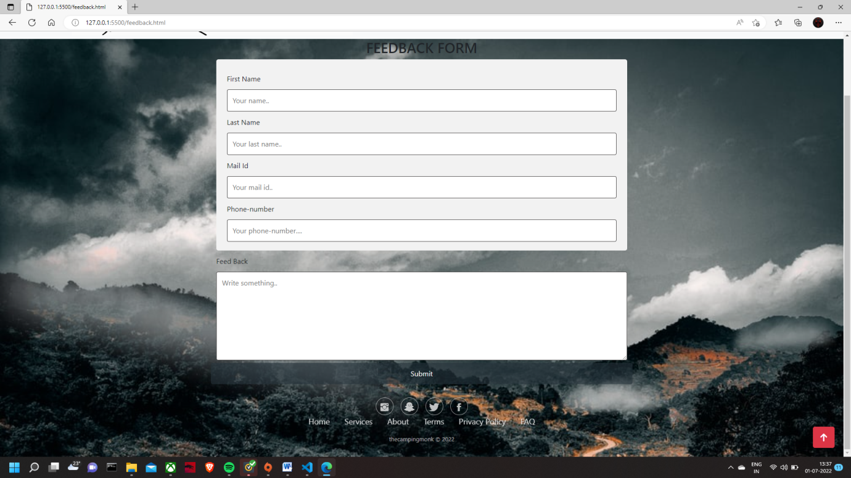

**8. CONTACT US**

 <section

      class="ftco-section img bg-hero"

      style="background-image: url(images/bailey-zindel-NRQV-hBF10M-unsplash.jpg)" >

      <div class="container-fluid">

        <div class="row justify-content-center">

          <div class="col-md-6 text-center mb-5">

          </div>

        <div class="row justify-content-center">

          <div class="col-lg-11">

            <div class="wrapper">

              <div class="row no-gutters justify-content-between">

                <div class="col-lg-6 d-flex align-items-stretch">

                  <div class="info-wrap w-100 p-5">

                    <h3 class="mb-4">Contact us</h3>

                    <div class="dbox w-100 d-flex align-items-start">

                      <div

                        class="icon d-flex align-items-center justify-content-center"

                      >

                        <span class="fa fa-map-marker"></span>

                      </div>

                      <div class="text pl-4">

                        <p>

                          <span>Address:</span> GAURAV RANA(@THE CAMPING MONK)

                        </p>

                      </div>

                    </div>

                    <div class="dbox w-100 d-flex align-items-start">

                      <div

                        class="icon d-flex align-items-center justify-content-center"

                      >

                        <span class="fa fa-phone"></span>

                      </div>

                      <div class="text pl-4">

                        <p>

                          <span>Phone:</span>

                          <a href="tel://1234567920">+91 8968753377, +91 7834053577</a>

                        </p>

                      </div>

                    </div>

                    <div class="dbox w-100 d-flex align-items-start">

                      <div

                        class="icon d-flex align-items-center justify-content-center"

                      >

                        <span class="fa fa-paper-plane"></span>

                      </div>

                      <div class="text pl-4">

                        <p>

                          <span>Email:</span>

                          <a href="#"

                              >

                              CONTACT@THECAMPINGMONK.COM

                        </p>

                      </div>

                    </div>

                    <div class="dbox w-100 d-flex align-items-start">

                      <div

                        class="icon d-flex align-items-center justify-content-center"

                      >

                        <span class="fa fa-globe"></span>

                      </div>

                      <div class="text pl-4">

                        <p><span>Website</span> <a href="#"> wwww.thecampingmonk.in</a></p>

                      </div>

                    </div>

                  </div>

                </div>

                <div class="col-lg-5">

                  <div class="contact-wrap w-100 p-md-5 p-4">

                    <h3 class="mb-4">Get in touch</h3>

                    <div id="form-message-warning" class="mb-4"></div>

                    <div id="form-message-success" class="mb-4">

                      Your message was sent, thank you!

                    </div>

                    <form method="POST" id="contactForm" name="contactForm">

                      <div class="row">

                        <div class="col-md-12">

                          <div class="form-group">

                            <input

                              type="text"

                              class="form-control"

                              name="name"

                              id="name"

                              placeholder="Name"

                            />

                          </div>

                        </div>

                        <div class="col-md-12">

                          <div class="form-group">

                            <input

                              type="email"

                              class="form-control"

                              name="email"

                              id="email"

                              placeholder="Email"

                            />

                          </div>

                        </div>

                        <div class="col-md-12">

                          <div class="form-group">

                            <input

                              type="text"

                              class="form-control"

                              name="subject"

                              id="subject"

                              placeholder="Subject"

                            />

                          </div>

                        </div>

                        <div class="col-md-12">

                          <div class="form-group">

                            <textarea

                              name="message"

                              class="form-control"

                              id="message"

                              cols="30"

                              rows="5"

                              placeholder="Message"

                            ></textarea>

                          </div>

                        </div>

                        <div class="col-md-12">

                          <div class="form-group">

                            <input

                              type="submit"

                              value="Send Message"

                              class="btn btn-primary"

                            />

                            <div class="submitting"></div>

                          </div>

                        </div>

                      </div>

                    </form>

                  </div>

                </div>

              </div>

            </div>

          </div>

        </div>

      </div>

    </div>

    </section>

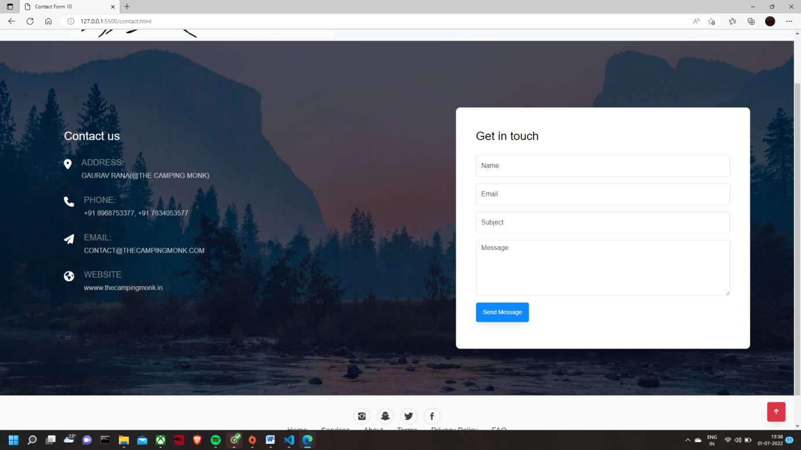

**9.ONLINE BOOKING**

[**a real**](https://www.lawinsider.com/dictionary/online-booking)-time online booking service made available to Agents and Clients to allow Agents and Clients to access the Company’s Services and various Tour products, including Inventory, rates and other details relating to various of the Company and third party services and products, which affords the Agent and Client the opportunity to make online bookings of the Company’s products and services, as well as enabling the Agent and Client to request bookings relating to products and services of certain third parties;

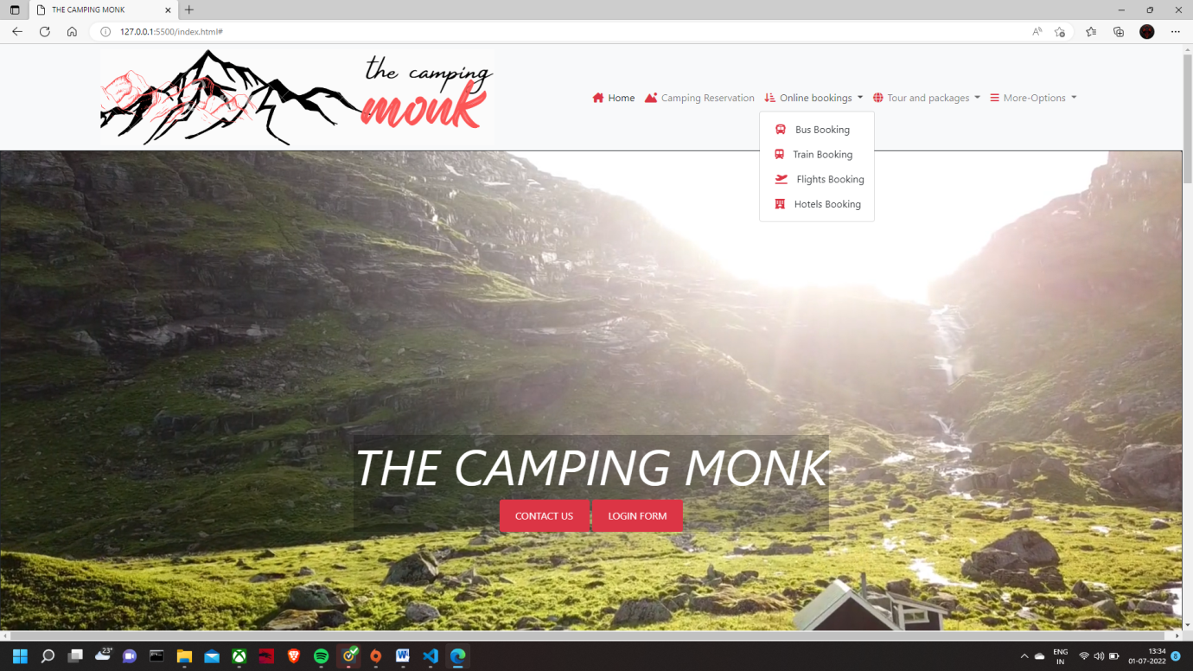

**8.1BUS BOOKING:-**

    <form>

      <div class="from-to">

        <section>

          <label for="departure">Departure</label>

          <select name="from" id="departure" required>

            <option value="ahmedabad">Ahmedabad</option>

            <option value="1">Surat</option>

            <option value="1">Vadodra</option>

            <option value="1">Rajkot</option>

            <option value="1">Bhavnagar</option>

            <option value="1">Jamnagar</option>

            <option value="1">Junagadh</option>

            <option value="1">Gandhinagar</option>

            <option value="1">Gandhidam</option>

            <option value="1">Anand</option>

            <option value="1">Navsari</option>

   <option value="1">Serchhip</option>

            <option value="1">Saiha</option>

            <option value="1">Lawngtlai</option>

          </select>

        </section>

      </div>

 <div class="date" id="time">

        <label for="time">Date of departure</label>

        <input type="date" required />

      </div>

      <div class="date" id="time">

        <label for="time">Date of return</label>

        <input type="date" />

      </div>

      <div class="passengers">

        <section>

          <label for="adults">Adults</label>

          <input

            type="number"

            id="adults"

            name="Adults"

            min="1"

            max="10"

            value="1"

            required

          />

        </section>

        <section>

          <label for="children">Children</label>

          <input

            type="number"

            id="children"

            name="children"

            min="0"

            max="10"

            value="0"

          />

        </section>

      </div>

      <div class="info">

        <section>

          <label for="mail">e-mail Address</label>

          <input type="email" name="email" id="mail" required />

        </section>

        <section>

          <label for="phone">Telephone number</label>

          <input type="tel" name="Phone" id="phone" minlength="10" required />

        </section>

      </div>

      <div class="identity">

        <section>

          <label for="identity">National Id</label>

          <input type="text" id="identity" name="National Id" required />

        </section>

        <section>

          <label for="rad">Piece of identity</label>

          <section>

            <span>

              <input

                type="radio"

                name="peice"

                value="adhaaar"

                id="adhaar"

                checked

              />

              <label for="cin">Adhaar card</label>

            </span>

            <span>

              <input type="radio" name="peice" value="Passport" id="pass" />

              <label for="pass">Passport</label>

            </span>

            <span>

              <input

                type="radio"

                name="peice"

                value="drive licence"

                id="drive"

              />

              <label for="drive">Drive licence</label>

            </span>

          </section>

        </section>

      </div>

      <input type="submit" formaction="payment.html" />

    </form>

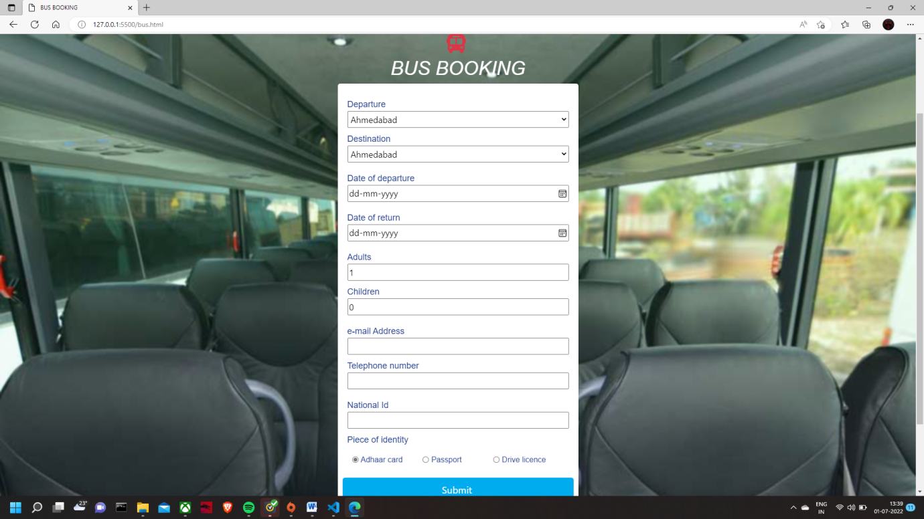

**8.2TRAIN BOOKING**

<form>

      <div class="from-to">

        <section>

          <label for="departure">Departure</label>

          <select name="from" id="departure" required>

            <option value="1">ATARIA</option>

            <option value="1">AMBIKA BHAWANI HALT</option>

            <option value="1">AMB ANDAURA</option>

            <option value="1">ANGAR</option>

            <option value="1">ITEHAR</option>

            <option value="1">ANKAI KILA</option>

            <option value="1">AMLAI</option>

            <option value="1">JHAROLA</option>

            <option value="1">ZARAP</option>

            <option value="1">ZAHIRABAD</option>

            <option value="1">ZAFARABAD JN</option>

            <option value="1">ZANKHVAV</option>

            <option value="1">JANGAON</option>

            <option value="1">ZAMANIA</option>

            <option value="1">ZINDPURA</option>

            <option value="1">ZERPUR PALI</option>

            <option value="1">ZAMPINI</option>

            <option value="1">ZANGALAPALLE</option>

            <option value="1">ZORAWAR PURA HALT</option>

            <option value="1">JHAJHPOR</option>

            <option value="1">ZIRADEI</option>

            <option value="1">JIRADEI</option>

            <option value="1">ZAWAR</option>

            <option value="1">BHAGALPUR</option>

          </select>

        </section>

      </div>

      <div class="date" id="time">

        <label for="time">Date of departure</label>

        <input type="date" required />

      </div>

      <div class="date" id="time">

        <label for="time">Date of return</label>

        <input type="date" />

      </div>

      <div class="passengers">

        <section>

          <label for="adults">Adults</label>

          <input

            type="number"

            id="adults"

            name="Adults"

            min="1"

            max="10"

            value="1"

            required

          />

        </section>

        <section>

          <label for="children">Children</label>

          <input

            type="number"

            id="children"

            name="children"

            min="0"

            max="10"

            value="0"

          />

        </section>

      </div>

      <div class="info">

        <section>

          <label for="mail">e-mail Address</label>

          <input type="email" name="email" id="mail" required />

        </section>

        <section>

          <label for="phone">Telephone number</label>

          <input type="tel" name="Phone" id="phone" minlength="10" required />

        </section>

      </div>

      <div class="identity">

        <section>

          <label for="identity">National Id</label>

          <input type="text" id="identity" name="National Id" required />

        </section>

        <section>

          <label for="rad">Piece of identity</label>

          <section>

            <span>

              <input

                type="radio"

                name="peice"

                value="adhaaar"

                id="adhaar"

                checked

              />

              <label for="cin">Adhaar card</label>

            </span>

            <span>

              <input type="radio" name="peice" value="Passport" id="pass" />

              <label for="pass">Passport</label>

            </span>

            <span>

              <input

                type="radio"

                name="peice"

                value="drive licence"

                id="drive"

              />

              <label for="drive">Drive licence</label>

            </span>

          </section>

        </section>

      </div>

   <input type="submit" formaction="payment.html" />

    </form>

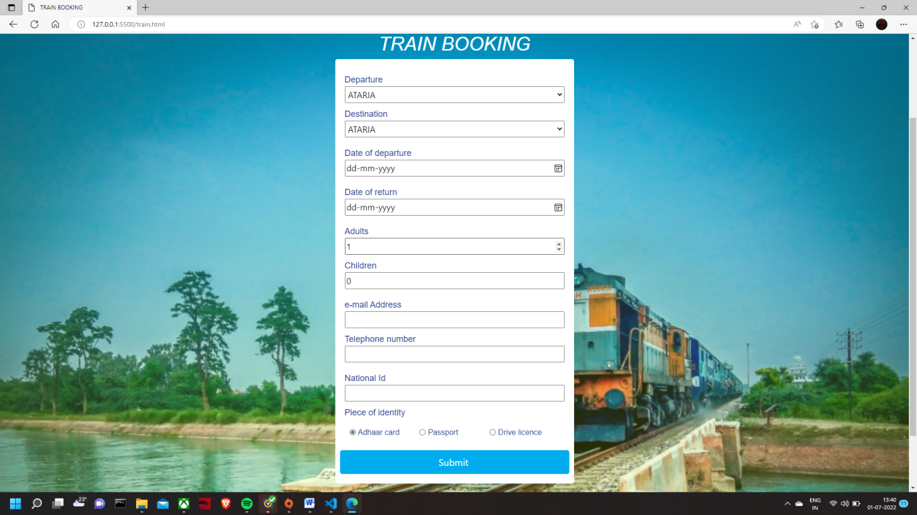

**8.3HOTEL BOOKING**

<form action="reservation.php" method="post">

      <div class="elem-group">

        <h1>

          <center>

            <i class="fa-solid fa-hotel p-2"></i>

            HOTEL BOOKING

          </center>

        </h1>

        <label for="name">Your Name</label>

        <input

          type="text"

          id="name"

          name="visitor_name"

          placeholder="eg. Kartik Singh"

          required

        />

      </div>

      <div class="elem-group">

        <label for="email">Your E-mail</label>

        <input

          type="email"

          id="email"

          name="visitor_email"

          placeholder="abc@email.com"

          required  />

      </div>

      <div class="elem-group">

        <label for="phone">Your Phone</label>

        <input

          type="tel"

          id="phone"

          name="visitor_phone"

          placeholder="012-345-6789"

          required

        />

      </div>

      <div class="elem-group">

        <label for="destination">Your destination</label>

        <input

          type="text"

          id="destination"

          name="visitor_phone"

          placeholder="eg. Royal Palace Dharamshala"

          required

        />

      </div>

      <hr />

      <div class="elem-group inlined">

        <label for="adult">Adults</label>

        <input

          type="number"

          id="adult"

          name="total_adults"

          placeholder="2"

          min="1"

          required

        />

      </div>

      <div class="elem-group inlined">

        <label for="child">Children</label>

        <input

          type="number"

          id="child"

          name="total_children"

          placeholder="2"

          min="0"

          max="10"

          required

        />

      </div>

      <div class="elem-group inlined">

        <label for="checkin-date">Check-in Date</label>

        <input type="date" id="checkin-date" name="checkin" required />

      </div>

      <div class="elem-group inlined">

        <label for="checkout-date">Check-out Date</label>

        <input type="date" id="checkout-date" name="checkout" required />

      </div>

      <div class="elem-group">

        <label for="room-selection">Select Room Preference</label>

        <select id="room-selection" name="room_preference" required>

          <option value="">Choose a Room from the List</option>

          <option value="connecting">Connecting</option>

          <option value="adjoining">Adjoining</option>

          <option value="adjacent">Adjacent</option>

        </select>

      </div>

      <hr />

      <div class="elem-group">

        <label for="message">Anything Else?</label>

        <textarea

          id="message"

          name="visitor_message"

          placeholder="Tell us anything else that might be important."

        ></textarea>

      </div>

      <button type="submit" formaction="payment.html">Book The Rooms</button>

    </form>

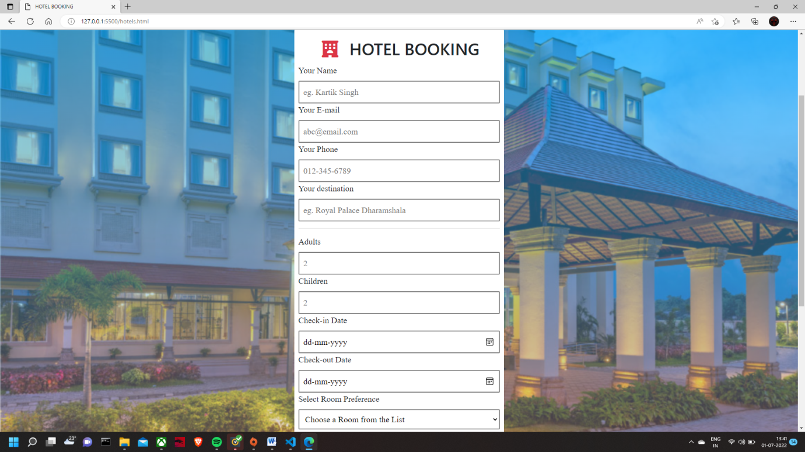

**8.4FLIGHT BOOKING**

 <form>

      <div class="from-to">

        <section>

          <label for="departure">Departure</label>

          <select name="from" id="departure" required>

            <option value="1">Agartala Singerbhil Airport (IXA)</option>

            <option value="1">Agatti Island Agatti Island Airport

            <option value="1">Agra Kheria Airport (AGR)</option>

            <option value="1">Ahmedabad Ahmedabad Airport (AMD)</option>

            <option value="1">Aizawl Aizawl Airport (AJL)</option>

            <option value="1">Akola Akola Airport (AKD)</option>

            <option value="1">Allahabad Bamrauli Airport (IXD)</option>

option value="1">Vijayawada Vijayawada Airport (VGA)</option>

            <option value="1">Visakhapatnam Visakhapatnam Airport (VTZ)</option>

            <option value="1">Warangal Warangal Airport (WGC)</option>

          </select>

        </section>

      </div>

 <div class="date" id="time">

        <label for="time">Date of departure</label>

        <input type="date" required />

      </div>

      <div class="passengers">

        <section>

          <label for="adults">Adults</label>

          <input

            type="number"

            id="adults"

            name="Adults"

            min="1"

            max="10"

            value="1"

            required

          />

        </section>

        <section>

          <label for="children">Children</label>

          <input

            type="number"

            id="children"

            name="children"

            min="0"

            max="10"

            value="0"

          />

        </section>

      </div>

      <div class="info">

        <section>

          <label for="mail">e-mail Address</label>

          <input type="email" name="email" id="mail" required />

        </section>

        <section>

          <label for="phone">Telephone number</label>

          <input type="tel" name="Phone" id="phone" minlength="10" required />

        </section>

      </div>

      <div class="identity">

        <section>

          <label for="identity">National Id</label>

          <input type="text" id="identity" name="National Id" required />

        </section>

        <section>

          <label for="rad">Piece of identity</label>

          <section>

            <span>

              <input

                type="radio"

                name="adhaar"

                value="adhaaar"

                id="adhaar"

                checked

              />

              <label for="adhaar">Adhaar card</label>

            </span>

            <span>

              <input type="radio" name="peice" value="Passport" id="pass" />

              <label for="pass">Passport</label>

            </span>

            <span>

              <input

                type="radio"

                name="peice"

                value="drive licence"

                id="drive"

              />

              <label for="drive">Drive licence</label>

            </span>

          </section>

        </section>

      </div>

      <input type="submit" formaction="payment.html" />

    </form>

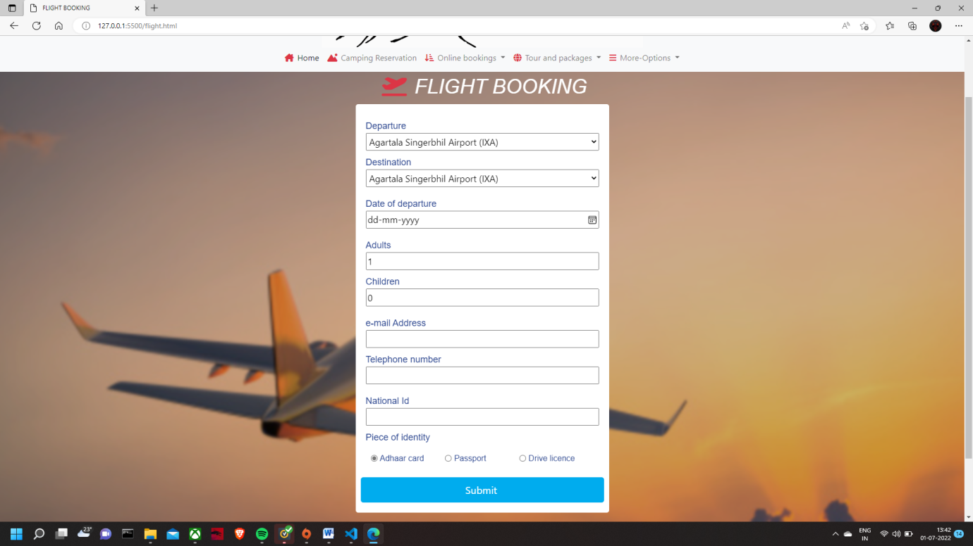

**10. ACCORDIAN FORM AND FREQUENTLY ASKED QUESTIONS**

The accordion uses [collapse](https://getbootstrap.com/docs/5.0/components/collapse/) internally to make it collapsible. To render an accordion that’s expanded, add the .open class on the .accordion

              <li class="nav-item dropdown">

                <a class="nav-link dropdown-toggle" href="#" id="navbarDropdown" role="button" data-bs-toggle="dropdown" aria-expanded="false">

            <i class="fa-solid fa-bars"></i>More-Options

                </a>

                <ul class="dropdown-menu" aria-labelledby="navbarDropdown">

                  <li><a class="dropdown-item" href="contact.html"><i class="fa-solid fa-people-arrows-left-right p-2""></i>Contact-us</a></li>

                  <li><a class="dropdown-item" href="enquiry.html"><i class="fa-solid fa-magnifying-glass p-2""></i>Enquiry</a></li>

                  <li><a class="dropdown-item" href="feedback.html"><i class="fa-solid fa-comments p-2""></i>Feedback</a></li>

                </ul>

              </li>

                        </ul>

                      </div>

        </div>

      </nav>

          <section id="QUESTIONS" >

      <h5 class=" text-center md-4 p-3" back>FREQUENTLY ASKED QUESTIONS</h5>

      <div class="accordion accordion-flush" id="QUESTIONS">

        <!--ITEM1-->

        <div class="accordion-item" >

          <h6 class="accordion-header" id="flush-headingOne">

          <button class="accordion-button collapsed" type="button" data-bs-toggle="collapse" data-bs-target="#QUESTION-1" >

           Where is the base camp located ?

          </button>

          <div id="QUESTION-1" class="accordion-collapse collapse" aria-labelledby="flush-headingOne" data-bs-parent="#accordionFlushExample">

            <div class="accordion-body">The main camping site is located exactly near the paragliding runway.It has parking space,the tents are of the best quality,clean and tidy sleeping bags and moreover the view is just outstanding.You will enjoy great food and here you have different kind of vibes.</div>

          </div>

        </div>

        <!--ITEM2-->

        <div class="accordion-item">

          <h6 class="accordion-header" id="flush-headingOne">

          <button class="accordion-button collapsed" type="button" data-bs-toggle="collapse" data-bs-target="#QUESTION-2" >

          What about treks and guides ?

          </button>

          <div id="QUESTION-2" class="accordion-collapse collapse" aria-labelledby="flush-headingOne" data-bs-parent="#accordionFlushExample">

            <div class="accordion-body">The camping monk have various others sites attached with them that will let you cover and explore all treks and native places in himachal pradesh with highly professional and skillful guides.</div>

          </div>

        </div>

        <!--ITEM3-->

      <div class="accordion-item">

        <h6 class="accordion-header" id="flush-headingOne">

        <button class="accordion-button collapsed" type="button" data-bs-toggle="collapse" data-bs-target="#QUESTION-3"   >

        what are the charges and facilities ?

        </button>

      <div id="QUESTION-3" class="accordion-collapse collapse" aria-labelledby="flush-headingOne" data-bs-parent="#accordionFlushExample">

      <div class="accordion-body">The cost depend upon what all things and activities the person wants, we have connection with atv riders, the paragliding people (the pilots),the other trekkers that are induldged in full-time trekking only and we have connection with travel agencies for good transport facilities.</div>

    </div>

      </div>

      <!--ITEM4-->

      <div class="accordion-item">

        <h6 class="accordion-header" id="flush-headingOne">

        <button class="accordion-button collapsed" type="button" data-bs-toggle="collapse" data-bs-target="#QUESTION-4" >

        what about booking ?

        </button>

              <div id="QUESTION-4" class="accordion-collapse collapse" aria-labelledby="flush-headingOne" data-bs-parent="#accordionFlushExample">

          <div class="accordion-body">The camping monk is a tour and travel company that provides packages all over INDIA's tourist places with the best tranportation and stay facilities at the best prices from the market, as we don't have any type of brokerage or third party access intermmediate. </div>

        </div>

      </div>

      </div>

    </section>

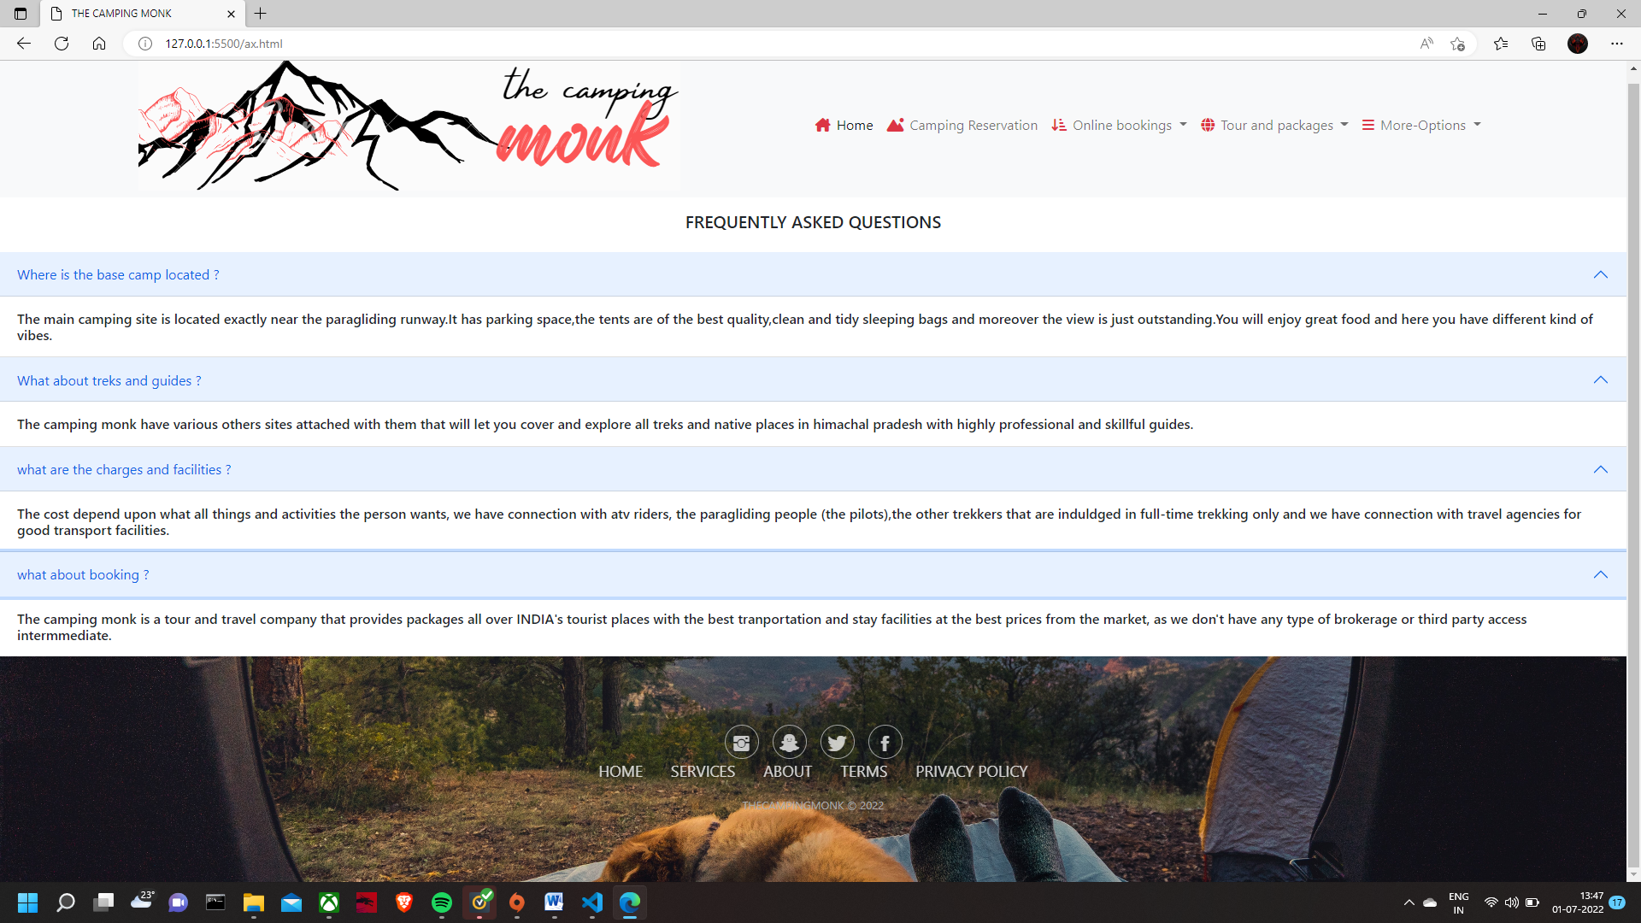

**11.PARALLAX METHOD**

Parallax scrolling is a web site trend where the background content (i.e. an image) is moved at a different speed than the foreground content while scrolling. Click on the links below to see the difference between a website with and without parallax scrolling.

/* Section - Parallax */

/**************************/

#parallax-world-of-ugg .parallax-one,

#parallax-world-of-ugg .parallax-two,

#parallax-world-of-ugg .parallax-three,

#parallax-world-of-ugg .parallax-four,

{

  padding-top: 50px;

  padding-bottom: 50px;

  overflow: hidden;

  position: relative;

  width: 100%;

  background-attachment: fixed;

  background-size: cover;

  -moz-background-size: cover;

  -webkit-background-size: cover;

  background-repeat: no-repeat;

  background-position: top center;

}

#parallax-world-of-ugg .parallax-one {

  background-image: url(https://images.unsplash.com/photo-1415018255745-0ec3f7aee47b?dpr=1&auto=format&fit=crop&w=1500&h=938&q=80&cs=tinysrgb&crop=);

}

#parallax-world-of-ugg .parallax-two {

  background-image: url(/images/benjamin-voros-phIFdC6lA4E-unsplash.jpg);

}

#parallax-world-of-ugg .parallax-three {

  background-image: url(https://images.unsplash.com/photo-1440688807730-73e4e2169fb8?dpr=1&auto=format&fit=crop&w=1500&h=1001&q=80&cs=tinysrgb&crop=);

}

#parallax-world-of-ugg .parallax-four {

  background-image: url(/images/john-towner-JgOeRuGD_Y4-unsplash.jpg);

**12. TOUR AND PACKAGES**

Package holidays, popularly known as a tour package or simply the word ‘tour’ in the travel and tourism industry refers either to a package tour escorted or not escorted by the tourist guide.

When we say tour package, it means a pre-arrangement, prepaid trip that combines two or more travel components like airfare, airport transfer, accommodation, and other services. Practically, to define the tour package concept is complex one rather understand

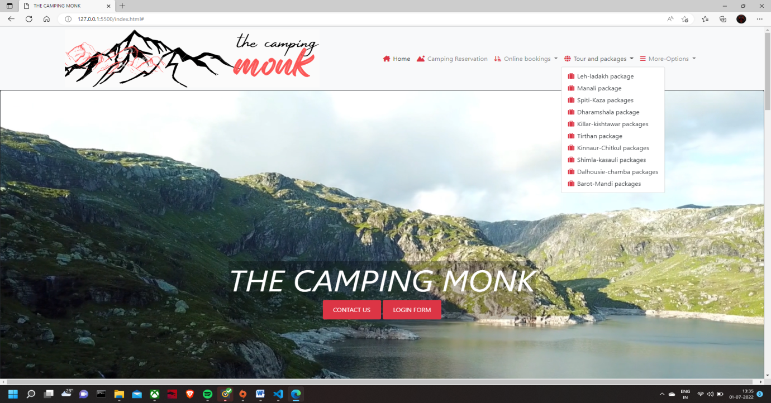

**LEH LADAKH PACKAGE**

<div id="parallax-world-of-ugg">

  <section>

    <div class="parallax-thirty ">

          </div>

          </section>

             <div class="card bg-dark text-center text-white text-uppercase">

                    <div class="card-body">

            <h5 class="card-title text-center">LEH-LADAKH  ITENARY</h5>

                        <p class="card-text "> <span class="h3" >Day 1 </span> | Delhi – Manali/Solang Valley<br/>

                                Better stay at Solang Valley and avoid Manali as sleeping at Solang Valley does help in acclimatization<br/>

                                If going by own car, get the permit made in advance to drive on Manali – Rohtang Pass road<br/>

                  Overnight at Manali/Solang Valley

                  </p>

        </div>

      </div>

          </div>

       <div class="card bg-dark text-white  text-center text-uppercase">

        <img src="/images/L1.jpg" class="card-img-top" alt="...">

   <div class="card-body">

        <p class="card-text "><span class="h3" >Day 2 </span> |  Manali/Solang Valley – Keylong/Jispa<br/>

    It's better to stay either at Keylong/Jispa so that you do not feel sick or hit by AMS<br/>

prefer staying at Jispa more because Keylong gives the feeling of a town while Jispa is closer to nature having Bhaga river running just aside the Manali – Leh Highway at Jispa.<br/>

Overnight at Keylong/Jispa<br/>

About 6-7 Hrs drive, depending upon the breaks you take in between<br/>

               </p>

      </div>

 </div>

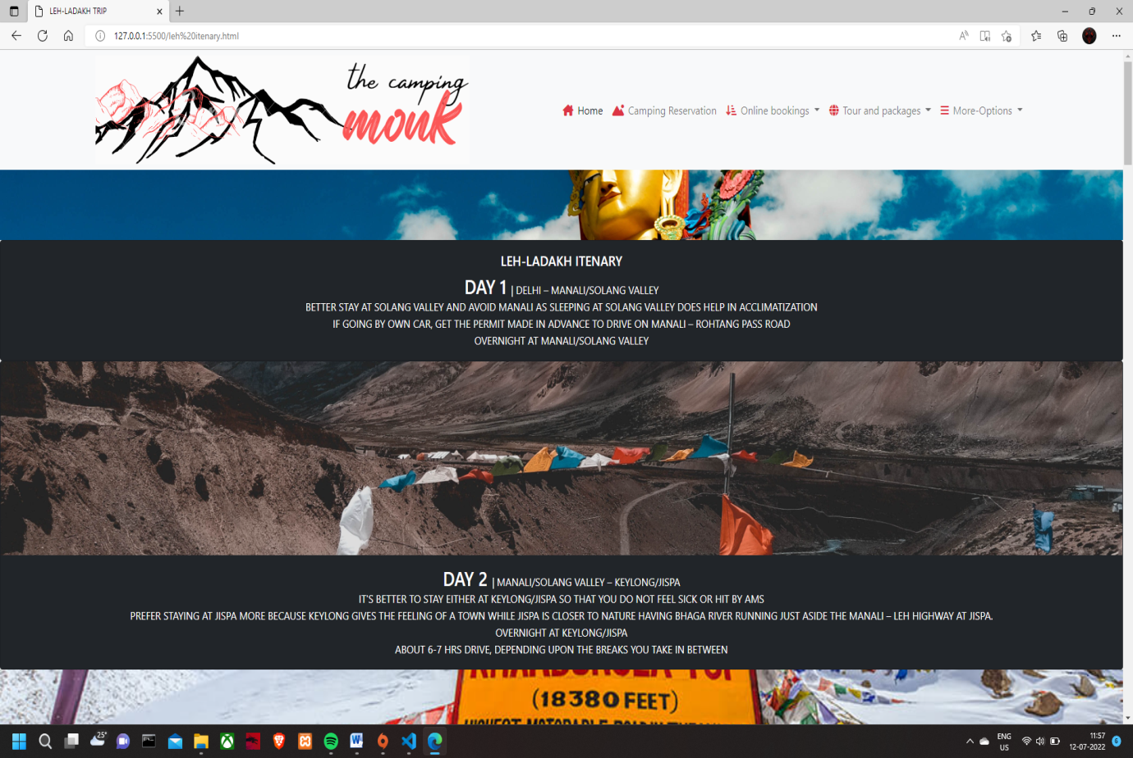

**MANALI PACKAGES**

<div id="parallax-world-of-ugg">

  <section>

    <div class="parallax-fifty">

          </div>

          </section>

    <div class="card bg-dark  text-white  text-center text-uppercase">

      <div class="card-body">

        <h5 class="card-title text-center">MANALI ITENARY</h5>

        <p class="card-text "><span class="h3" >Day 1</span> | Delhi – Manali<br/>

                            Take a day rest and explore local market as you have already travelled for more than 12hrs in transportation.

                           </p>

        </div>

 </div>

 </div>

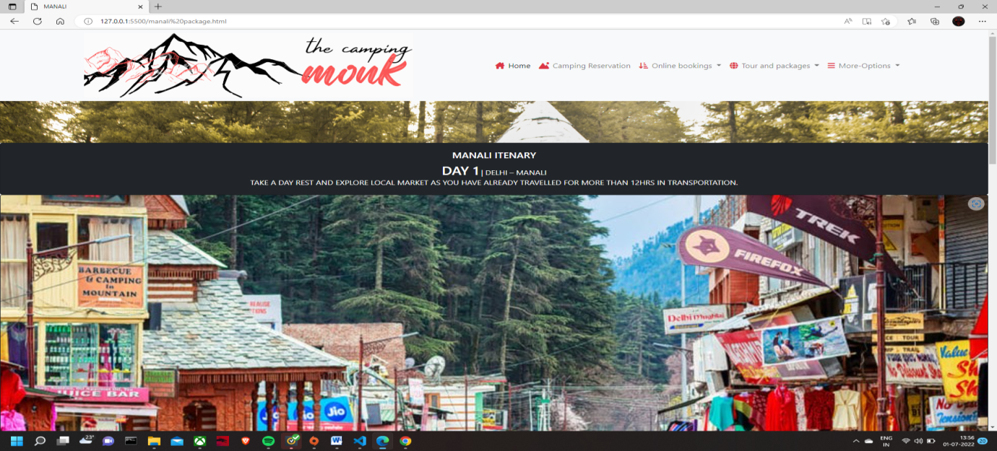

**SPITI KAZA PACKAGES**

 <div id="parallax-world-of-ugg">

  <section>

    <div class="parallax-fiftyeight">

          </div>

          </section>

    <div class="card bg-dark  text-white  text-center text-uppercase">

            <div class="card-body">

        <h5 class="card-title text-center">KAZA-SPITI ITENARY</h5>

        <p class="card-text "><span class="h3" >Day 1</span> | Arrival in Manali | A Paradise for Nature Lovers and Adventure Enthusiasts<br/>

                       Reach Manali early in the morning and meet a representative who will help you with the smooth transfer to the hotel.<br/>

On reaching the hotel, complete the check-in formalities and have a hearty breakfast.<br/>

After resting for a while, it's time to head towards Manali for local sightseeing.<br/>

The sightseeing will start with full enthusiasm and you will be visiting the famous Hadimba temple, Buddhist temple, Clubhouse, Siyali Mahadev, Van Vihar and Old Manali.<br/>

Along with the same, you will be able to click multiple pictures to create wonderful memories.<br/>

Return back to the hotel in Manali for an overnight stay<br/>

               </p>

      </div>

  </div>

  </div>

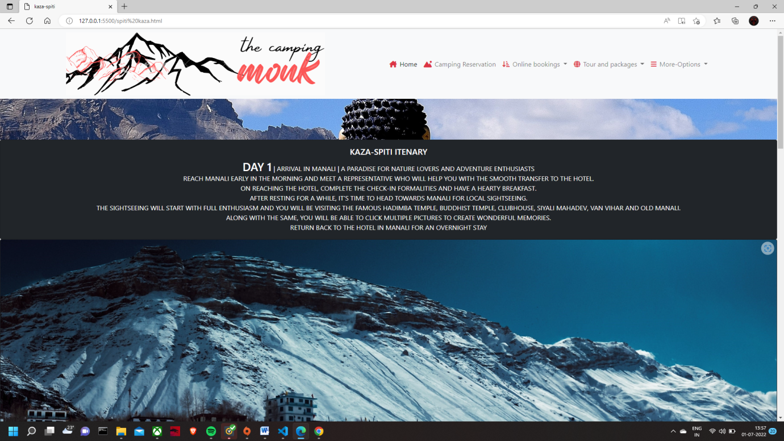

**DHARAMSHALA PACKAGES**

<div id="parallax-world-of-ugg">

    <section>

      <div class="parallax-fortythree">

            </div>

            </section>

    <div class="card bg-dark text-white  text-center text-uppercase">

           <div class="card-body">

        <h5 class="card-title text-center">DHARAMSHALA ITENARY</h5>

        <p class="card-text "><span class="h3" >Day 1</span>  | Reach Dharamshala<br/>

                          McLeod Ganj:-McLeod Ganj is a suburb in the state of Himachal Pradesh. It is also popularly known as "Little Lhasa" or "Dhasa". <br/>

              The city has got this name due to the large populations of Tibetans. Also, the famous Tibetan government-in-exile has its headquarters in this city.<br/>

              Without any doubt, McLeodganj is the best place to visit near Dharamshala.   <br/>

              Dharamkot:- Dharamkot is a place for all the hill station lovers. It is a small hill station located in the Kangra district just above McLeod Ganj. The elevation of the hill station is around 2827m.<br/>

              One of the most interesting things about the place is that many foreigners have started living in the area because they liked it so much.<br/>

               </p>

    </div>

      </div>

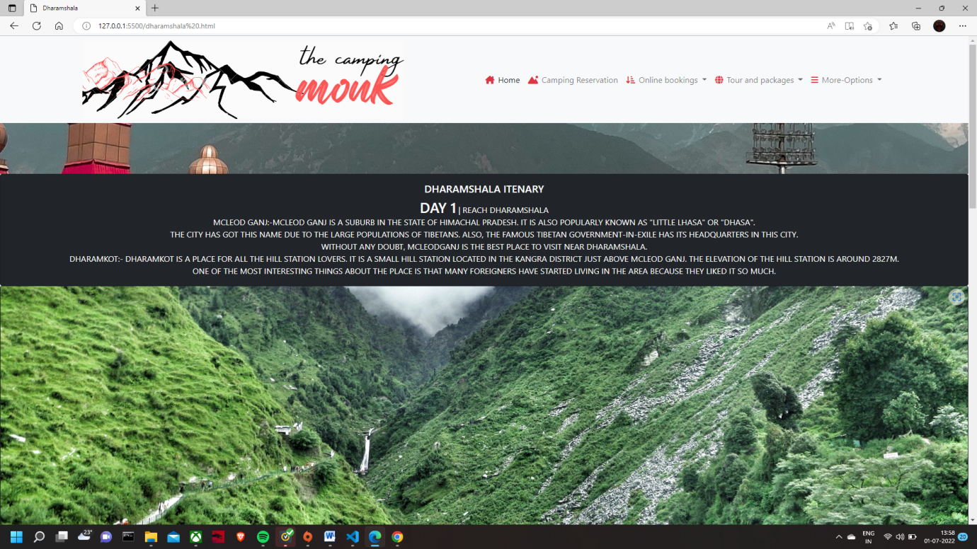

**KILLAR KISHTWAR PACKAGES**

<div id="parallax-world-of-ugg">

  <section>

    <div class="parallax-fortysix">

          </div>

          </section>

    <div class="card bg-dark  text-white  text-center text-uppercase">

        <div class="card-body">

        <h5 class="card-title text-center">KILLAR TO KISHTWAR ITENARY</h5>

        <p class="card-text "><span class="h3" >Day 1</span>  | DELHI-MANALI | 222 – 2050 MTS ASL | 538 KMS<br/>

  Start from Delhi on your bike or bus<br/>

  Reach Manali as per your convinience<br/>

               </p>

      </div>

  </div>

</div>

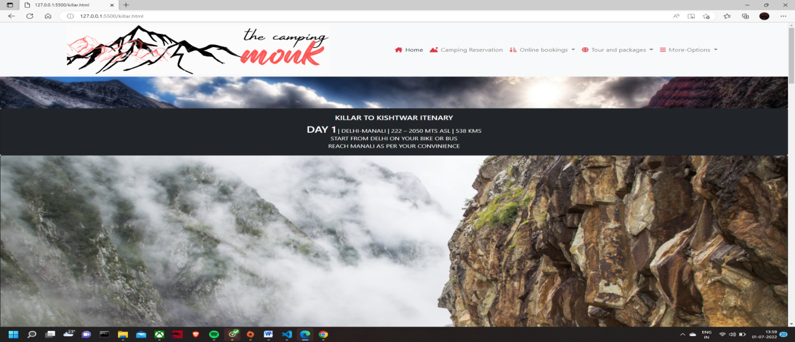

**TIRTHAN PACKAGES**

 <div id="parallax-world-of-ugg">

  <section>

    <div class="parallax-sixtyone">

          </div>

          </section>

    <div class="card bg-dark  text-white  text-center text-uppercase">

          <div class="card-body">

        <h5 class="card-title text-center">TIRTHAN VALLEY ITENARY</h5>

        <p class="card-text "><span class="h3" >Day 1</span> | ( DELHI – AUT (470 KMS/10-11 HRS) )<br/>

 Start your wonderful journey to Himachal till Aut by boarding the Volvo from Delhi Volvo pick up point (Guests are requested to report at scheduled time). <br/>

 Overnight Journey will be by Volvo.<br/>

               </p>

      </div>

  </div>

 </div>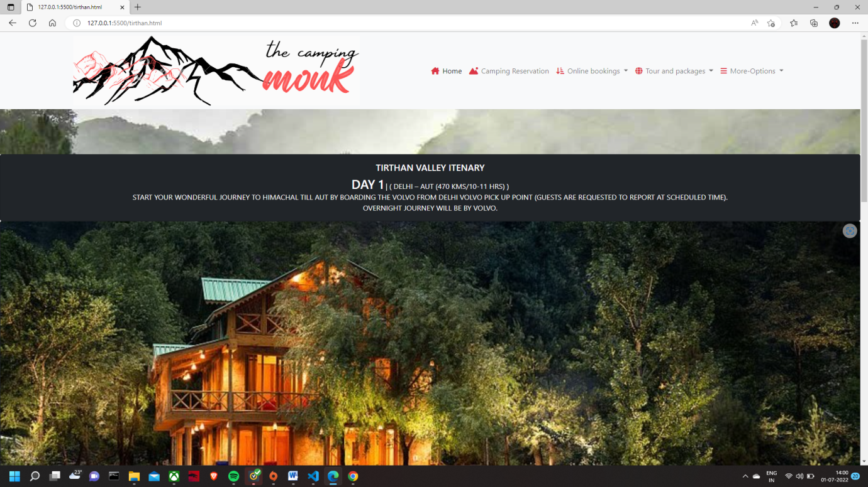

**KINNAUR CHITKUL PACKAGES**

<div id="parallax-world-of-ugg">

  <section>

    <div class="parallax-thirtyeight">

          </div>

          </section>

    <div class="card bg-dark text-white  text-center text-uppercase">

          <div class="card-body">

        <h5 class="card-title text-center">SANGLA CHITKUL ITENARY </h5>

        <p class="card-text "><span class="h3" >Day 1 </span>  | Arrival in Shimla<br/>

You will be coming across the representative local guide who will assist you in the transfer to Shimla on a drive.<br/>

 Soon after you arrive in Shimla, check-in the hotel and stay overnight after having dinner..<br/>

               </p> </div>

      </div>

  </div>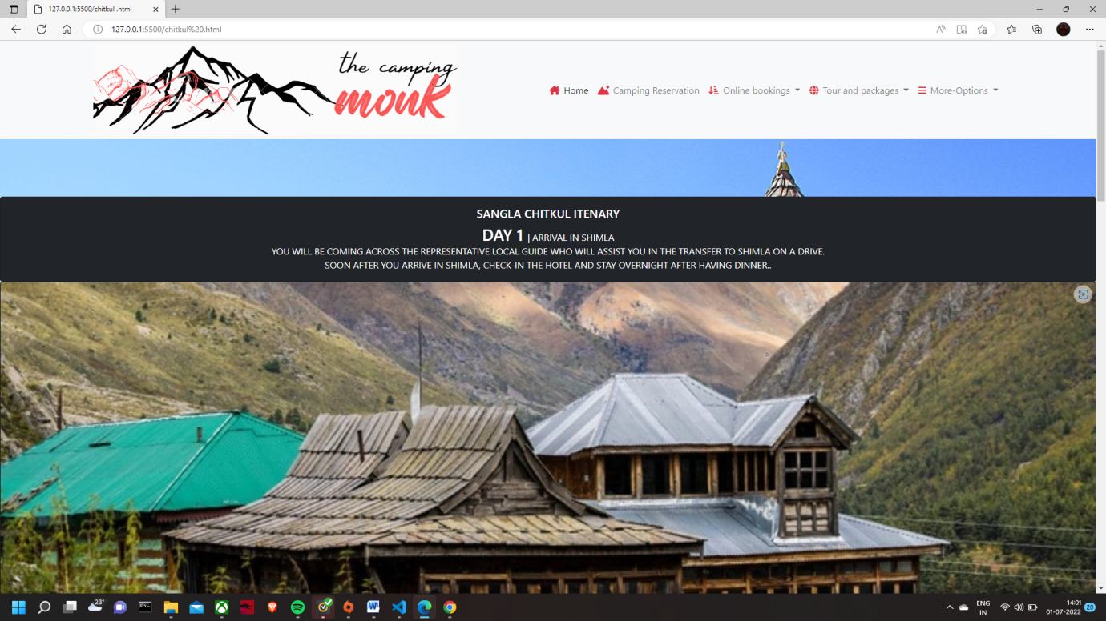

**SHIMLA KASAULI PACKAGES**

<div id="parallax-world-of-ugg">

  <section>

    <div class="parallax-fiftysix">

          </div>

          </section>

    <div class="card bg-dark  text-white  text-center text-uppercase">

           <div class="card-body">

        <h5 class="card-title text-center">SHIMLA KASAULI ITENARY</h5

        <p class="card-text "><span class="h3" >Day 1</span> | Chandigarh and Kasauli; Visit the Rock Garden and check out the Gilbert Nature Trail<br/>

Arrive in Chandigarh and set out to sightsee the famous Rock Garden, known for its numerous sculptures made using a variety of different discarded waste<br/>

Drive down to Kasauli and check-in at the homestay/resort<br/>

Post a hearty lunch, visit the Gilbert Nature Trail and explore the flora and fauna here<br/>

Return back to the homestay and enjoy an overnight stay<br/>

               </p>

      </div>

  </div>

  </div>

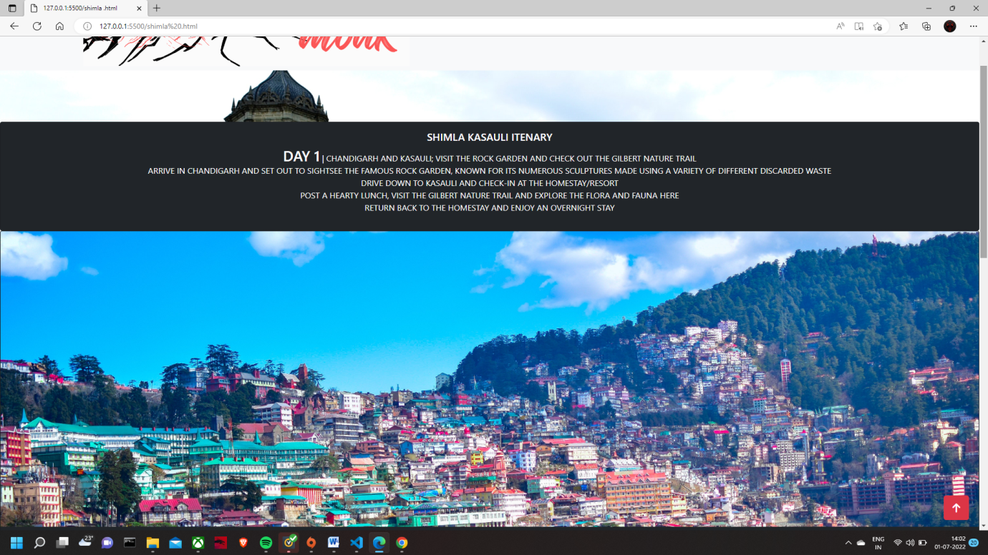

**DALHOUSIE CHAMBA PACKAGES**

  <div id="parallax-world-of-ugg">

    <section>

      <div class="parallax-forty ">

            </div>

            </section>

    <div class="card bg-dark text-white  text-center text-uppercase">

       <div class="card-body">

        <h5 class="card-title text-center">DALHOUSIE-CHAMBA ITENARY</h5>

        <p class="card-text "><span class="h3" >Day 1</span> |  Arrival at Dalhousie<br/>

Dalhousie Khajjiar tour package commences from Pathankot. Upon your arrival at Pathankot railway station you will meet our representative and will be transferred to Dalhousie.<br/>

As you reach, check-in at the hotel and have some rest, later head out to explore this tinsel hill station.<br/>

Dalhousie Khajjiar tour packages invite you to visit the colonial-era buildings like St. Francis and St. John’s churches, built in the 1800s.<br/>

Later visit the Dainkund peak and spend some quality time at Chamera lake.<br/>

ead back to the hotel for an overnight stay as the first day of your Dalhousie Khajjiar tour plan ends here.<br/>

               </p>

      </div>

  </div>

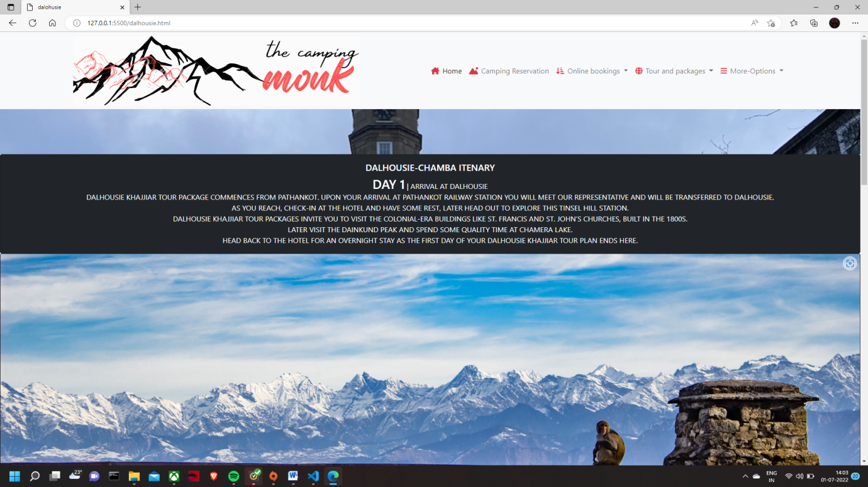

**MANDI-BAROT PACKAGES**

      <div id="parallax-world-of-ugg">

  <section>

    <div class="parallax-fiftytwo">

          </div>

          </section>

    <div class="card bg-dark  text-white  text-center text-uppercase">

          <div class="card-body">

        <h5 class="card-title text-center">MANDI ITENARY</h5>

        <p class="card-text "><span class="h3" >Day 1</span> | Arrival at Barot<br/>

Upon arrival at the bus station, meet our representative and reach the campsite by 4 pm in the evening.<br/>

After having welcome tea and evening snacks, start your Barot Valley tour P\packages by exploring the valley.<br/>

Enjoy the leisure time visiting nearby places like Barot market, crop fields or you can take a peaceful walk amidst the cedar forest and spend some quality time near the Uhl river.<br/>

Head back to the campsite for dinner.<br/>

Enjoy the first campfire of your Barot Valley Packages and then head to your tent for a sound sleep.<br/>

     </p> </div>

  </div>

  </div

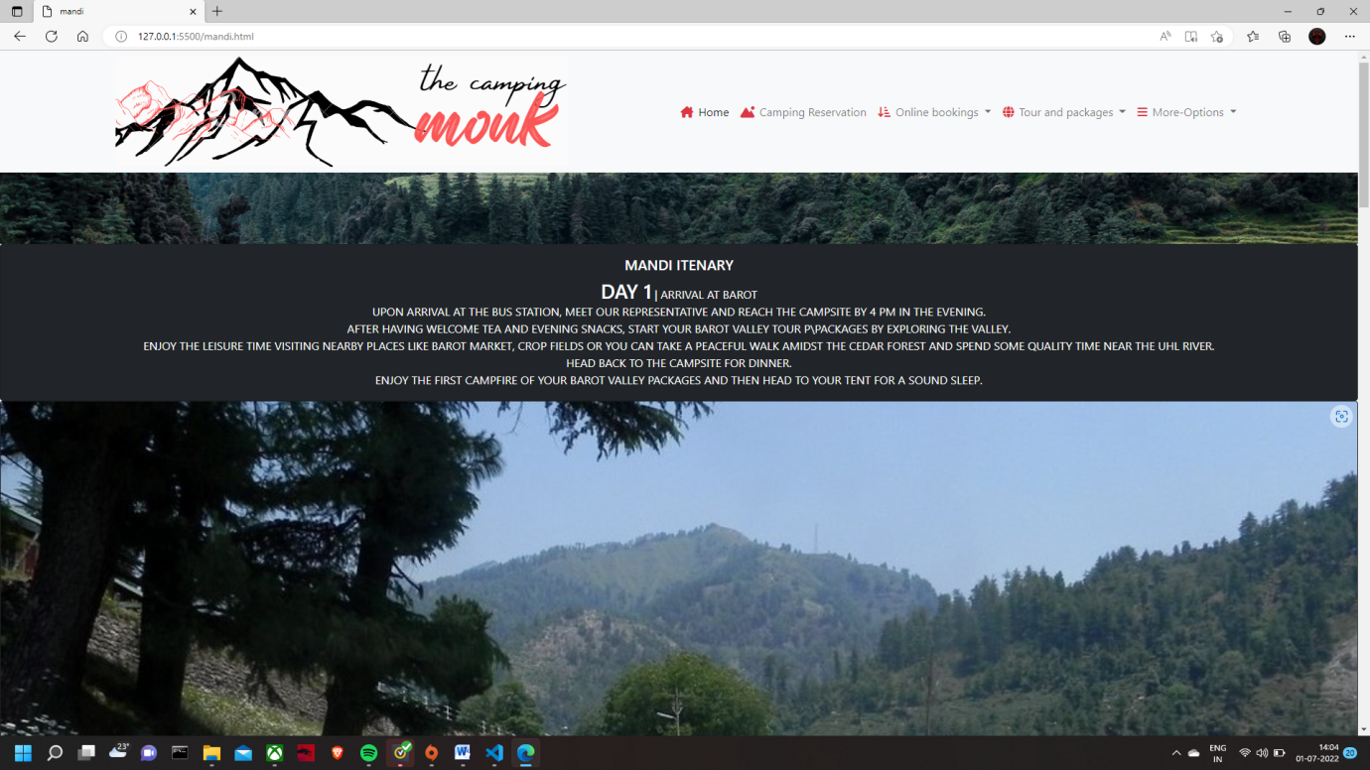

**13. FONT AWSOME ICONS:-**

Font Awesome 5 has a PRO edition with 7842 icons, and a FREE edition with 1588 icons. This tutorial will concentrate on the FREE edition.

To use the Free Font Awesome 5 icons, you can choose to download the Font Awesome library, or you can sign up for an account at Font Awesome, and get a code (called KIT CODE) to use when you add Font Awesome to your web page.

<head>  
<script src="https://kit.fontawesome.com/a076d05399.js" crossorigin="anonymous"></script>  
</head>  
<body>  
  
<i class="fas fa-clock"></i>  
  
</body>

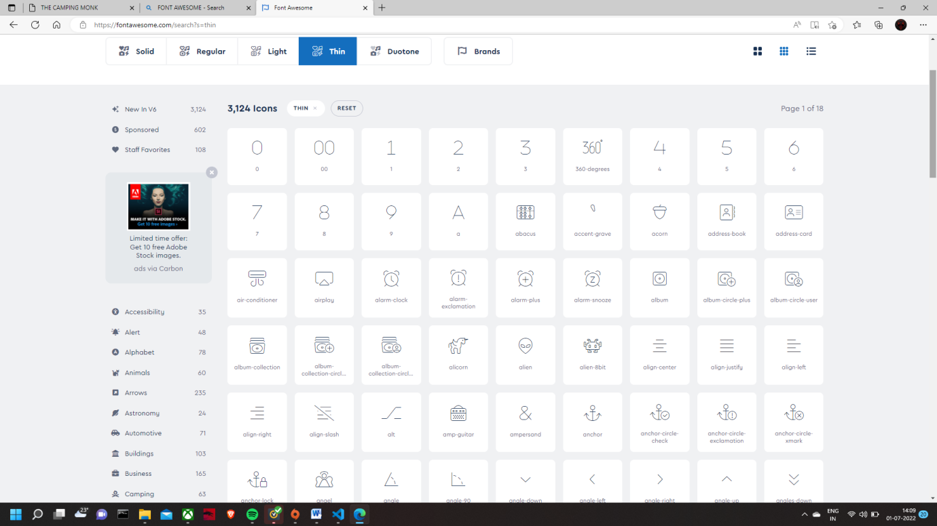

**14.CASCADING STYLE SHEET**

CSS stands for Cascading Style Sheets

CSS describes how HTML elements are to be displayed on screen, paper, or in other media

CSS saves a lot of work. It can control the layout of multiple web pages all at once

External stylesheets are stored in CSS files

Cascading Style Sheets, fondly referred to as CSS, is a simply designed language intended to simplify the process of making web pages presentable. CSS allows you to apply styles to web pages. More importantly, CSS enables you to do this independent of the HTML that makes up each web page. It describes how a webpage should look: it prescribes colors, fonts, spacing, and much more. In short, you can make your website look however you want. CSS lets developers and designers define how it behaves, including how elements are positioned in the browser.

CSS saves time: You can write CSS once and reuse the same sheet in multiple HTML pages.

Easy Maintenance: To make a global change simply change the style, and all elements in all the webpages will be updated automatically.

Search Engines: CSS is considered a clean coding technique, which means search engines won’t have to struggle to “read” its content.

Superior styles to HTML: CSS has a much wider array of attributes than HTML, so you can give a far better look to your HTML page in comparison to HTML attributes.

Offline Browsing: CSS can store web applications locally with the help of an offline cache. Using this we can view offline websites.

**14.1 COLORS:-** The color code can be one of:

Hex format: #rrggbb

RGB format: rgb(red, green, blue)

Name format: *name*

i.fa-solid {

  color: #dc3545;

  margin-right: 7px;

**14.2 .MEDIA:-** Media query is a CSS technique introduced in CSS3.

It uses the @media rule to include a block of CSS properties only if a certain condition is true.

Media queries can help with that. We can add a breakpoint where certain parts of the design will behave differently on each side of the breakpoint.

Mobile First means designing for mobile before designing for desktop or any other device (This will make the page display faster on smaller devices).

This means that we must make some changes in our CSS.

Instead of changing styles when the width gets *smaller* than 768px, we should change the design when the width gets *larger* than 768px.

@media (max-width: 768px) {

  .card-img-overlay {

    position: relative;

    width: 100%;

  }

}

@import url(https://fonts.googleapis.com/css?family=Oswald:300,400,700);

@import url(https://fonts.googleapis.com/css?family=Source+Sans+Pro:200,300,400,600,700,900,200italic,300italic,400italic,600italic,700italic,900italic);

#parallax-world-of-ugg h1 {

  font-family: "Oswald", sans-serif;

}

#parallax-world-of-ugg h2 {

  font-family: "Oswald", sans-serif;

  font-size: 70px;

  letter-spacing: 10px;

}

#parallax-world-of-ugg h3 {

  font-family: "Oswald", sans-serif;

  letter-spacing: 8px;

}

.first-character {

  font-weight: 400;

  float: left;

  font-size: 84px;

  line-height: 64px;

  padding-top: 4px;

  padding-right: 8px;

  padding-left: 3px;

  font-family: "Source Sans Pro", sans-serif;

}

.sc {

  color: #3b8595;

}

.ny {

  color: #3d3c3a;

}

.atw {

  color: #c48660;

}

With the help of css we can deign the pages , make it much more attractive and enhanced. It is used in front end design and thus making website attractive.

**14.3BACKGROUND:-** The CSS background properties are used to add background effects for elements.

With CSS, a color is most often specified by:

a valid color name - like "red"

a HEX value - like "#ff0000"

an RGB value - like "rgb(255,0,0)"

Eg:-

h1 {  
  background-color: green;  
}  
  
div {  
  background-color: lightblue;  
}  
  
p {  
  background-color: yellow;  
}

Background Image:- The background-image property specifies an image to use as the background of an element.

By default, the image is repeated so it covers the entire element.

<style>

body {

background-image: url("bgdesert.jpg");

}

</style>

Background-repeat

By default, the background-image property repeats an image both horizontally and vertically.

Some images should be repeated only horizontally or vertically, or they will look strange

body {  
  background-image: url("gradient_bg.png");  
  background-repeat: repeat-x;  
}

body {  
  background-image: url("img_tree.png");  
  background-repeat: no-repeat;  
}

**Background-attachment**:- The background-attachment property specifies whether the background image should scroll or be fixed (will not scroll with the rest of the page):

body {  
  background-image: url("img_tree.png");  
  background-repeat: no-repeat;  
  background-position: righttop;  
 background-attachment: fixed;  
}

Shorthand property:-To shorten the code, it is also possible to specify all the background properties in one single property. This is called a shorthand property.

body {  
 background-color: #ffffff;

background-image: url("img_tree.png");

background-repeat: no-repeat;  
 background-position: righttop;

CSS Margins

The CSS margin properties are used to create space around elements, outside of any defined borders.

With CSS, you have full control over the margins. There are properties for setting the margin for each side of an element (top, right, bottom, and left).

**Margin - Individual Sides**

CSS has properties for specifying the margin for each side of an element:

margin-top

margin-right

margin-bottom

margin-left

All the margin properties can have the following values:

auto - the browser calculates the margin

length - specifies a margin in px, pt, cm, etc.

% - specifies a margin in % of the width of the containing element

inherit - specifies that the margin should be inherited from the parent element

p {  
  margin-top: 100px;  
  margin-bottom: 100px;  
  margin-right: 150px;  
  margin-left: 80px;  
}

It has four properties

margin: 25px 50px 75px 100px;

top margin is 25px

right margin is 50px

bottom margin is 75px

left margin is 100px

**14.4 CSS Padding**

The CSS padding properties are used to generate space around an element's content, inside of any defined borders.

With CSS, you have full control over the padding. There are properties for setting the padding for each side of an element (top, right, bottom, and left).

Padding - Individual Sides

CSS has properties for specifying the padding for each side of an element:

padding-top

padding-right

padding-bottom

padding-left

All the padding properties can have the following values:

length - specifies a padding in px, pt, cm, etc.

% - specifies a padding in % of the width of the containing element

inherit - specifies that the padding should be inherited from the parent element

The padding property is a shorthand property for the following individual padding properties:

padding-top

padding-right

padding-bottom

padding-left

If the padding property has four values:

padding: 25px 50px 75px 100px;

top padding is 25px

right padding is 50px

bottom padding is 75px

left padding is 100px

**Rounded Corners:-** The CSS border-radius property defines the radius of an element's corners.

#rcorners1 {  
  border-radius: 25px;  
  background: #73AD21;  
  padding: 20px;  
  width: 200px;  
  height: 150px;  
}  
  
#rcorners2 {  
  border-radius: 25px;  
  border: 2px solid #73AD21;  
  padding: 20px;  
  width: 200px;  
  height: 150px;  
}  
  
#rcorners3 {  
  border-radius: 25px;  
  background: url(paper.gif);  
  background-position: left top;  
  background-repeat: repeat;  
  padding: 20px;  
  width: 200px;  
  height: 150px;  
}

Dropdown:-Create a dropdown box that appears when the user moves the mouse over an element.

<style>  
.dropdown {  
  position: relative;  
  display: inline-block;  
}  
  
.dropdown-content {  
  display: none;  
  position: absolute;  
  background-color: #f9f9f9;  
  min-width: 160px;  
  box-shadow: 0px 8px 16px 0px rgba(0,0,0,0.2);  
  padding: 12px 16px;  
  z-index: 1;  
}

**15. JAVA SCRIPT**

**JavaScript** is the world most popular lightweight, interpreted compiled programming language. It is also known as scripting language for web pages. It is well-known for the development of web pages, many non-browser environments also use it. JavaScript can be used for [**Client-side**](https://www.geeksforgeeks.org/server-side-client-side-programming/) developments as well as [**Server-side**](https://www.geeksforgeeks.org/server-side-client-side-programming/) developments.

JavaScript can be added to your HTML file in [two ways](https://www.geeksforgeeks.org/where-to-put-javascript-in-an-html-document/):

**Internal JS:** We can add JavaScript directly to our HTML file by writing the code inside the <script> tag. The <script> tag can either be placed inside the <head> or the <body> tag according to the requirement.

**External JS:** We can write JavaScript code in other file having an extension .js and then link this file inside the <head> tag of the HTML file in which we want to add this code.

<script>

    // Declare a variable and initialize it

    // Gloabal variable declaration

    var Name = "Apple";

    // Function definition

    function MyFunction() {

        // Local variable declaration

        var num = 45;

        // Display the value of Gloabal variable

        document.writeln(Name);

        // Display the value of local variable

        document.writeln("<br>" + num);

    }

      // Function call

    MyFunction();

</script>

**What is JavaScript used for?**

Web pages with interactive elements: User interaction with web pages is enabled through JavaScript. On a web page, JavaScript has essentially no bounds.

Developing online and mobile applications: For web and mobile app development, developers can employ a variety of JavaScript frameworks.

Creating web servers and server applications: Aside from websites and apps, developers may use JavaScript to create simple web servers and Node.js to construct backend infrastructure.

Game Development: Browser games can also be made using JavaScript. Beginning developers can use these to hone their JavaScript skills.

**<!-- Back to top button -->**

<button type="button" class="btn btn-danger btn-floating btn-lg" id="btn-back-to-top">

    <i class="fas fa-arrow-up"></i>

  </button>

    <!-- Explanation -->

     <script>

         //Get the button

  let mybutton = document.getElementById("btn-back-to-top");

  // When the user scrolls down 20px from the top of the document, show the button

  window.onscroll = function () {

  scrollFunction();

  };

  function scrollFunction() {

  if (

  document.body.scrollTop > 20 ||

  document.documentElement.scrollTop > 20

  ) {

  mybutton.style.display = "block";

  } else {

  mybutton.style.display = "none";

  }

  }

  // When the user clicks on the button, scroll to the top of the document

  mybutton.addEventListener("click", backToTop);

    function backToTop() {

  document.body.scrollTop = 0;

  document.documentElement.scrollTop =

**16. BOOTSTRAP CDN**

Bootstrap CDN is the distribution of the most popular CSS framework in the world using a content delivery network. It is a geographically distributed group of servers that work together to provide fast delivery of Internet content.

CDN enables a quick way to serve files over the internet such as HTML, Javascript, CSS, images, and videos. In Bootstrap’s case, the main Bootstrap javascript and stylesheet files are being served over a CDN network.

By default, Bootstrap recommends using Stackpath’s CDN network which already powers over 8 million websites across the globe..

**What are the benefits of using Bootstrap via CDN?**

*Improves website loading time* - Because the javascript and stylesheet files from Bootstrap will be loaded from a nearby server based on the geographical location of the website visitor, the loading time will be reduced. Imagine a visitor from Japan: if your Bootstrap files are hosted in the USA, loading time will be much slower than if you had a CDN that would also have servers set up in Asia;

*Reduced bandwidth cost* - Because the Bootstrap CDN is already used by over 8 million websites, chances are that a significant percentage of your website traffic will have the Bootstrap files cached in the local browser, making your website even faster;

*Improved website security* - Having content delivered via CDN may protect your website better against DDoS mitigation;

**How to use Bootstrap CDN?**

To get started using Bootstrap via the [official CDN](https://www.bootstrapcdn.com/) powered by StackPath, all you need to do is include the following stylesheet and javascript files. Include the following CSS file into the <head> tag of your HTML:

<link rel="stylesheet" href="https://stackpath.bootstrapcdn.com/bootstrap/4.5.2/css/bootstrap.min.css" integrity="sha384-JcKb8q3iqJ61gNV9KGb8thSsNjpSL0n8PARn9HuZOnIxN0hoP+VmmDGMN5t9UJ0Z" crossorigin="anonymous">

Afterward include jQuery, Popper.js, and Bootstrap’s Javascript file before the end of your **<body>** tag:

<script src="https://code.jquery.com/jquery-3.5.1.slim.min.js" integrity="sha384-DfXdz2htPH0lsSSs5nCTpuj/zy4C+OGpamoFVy38MVBnE+IbbVYUew+OrCXaRkfj" crossorigin="anonymous"></script>

<script src="https://cdn.jsdelivr.net/npm/popper.js@1.16.1/dist/umd/popper.min.js" integrity="sha384-9/reFTGAW83EW2RDu2S0VKaIzap3H66lZH81PoYlFhbGU+6BZp6G7niu735Sk7lN" crossorigin="anonymous"></script>

<script src="https://stackpath.bootstrapcdn.com/bootstrap/4.5.2/js/bootstrap.min.js" integrity="sha384-B4gt1jrGC7Jh4AgTPSdUtOBvfO8shuf57BaghqFfPlYxofvL8/KUEfYiJOMMV+rV" crossorigin="anonymous"></script>

**How to use Bootstrap 5 via CDN**

Although still not the stable version of Bootstrap, you may want to get started using Bootstrap 5 which removed jQuery as a dependency. Add the following stylesheet file in the <head> tag of your HTML template:

<link rel="stylesheet" href="https://stackpath.bootstrapcdn.com/bootstrap/5.0.0-alpha1/css/bootstrap.min.css" integrity="sha384-r4NyP46KrjDleawBgD5tp8Y7UzmLA05oM1iAEQ17CSuDqnUK2+k9luXQOfXJCJ4I" crossorigin="anonymous">

Lastly, add the following two Javascript files before the end of the <body> tag:

<script src="https://cdn.jsdelivr.net/npm/popper.js@1.16.0/dist/umd/popper.min.js" integrity="sha384-Q6E9RHvbIyZFJoft+2mJbHaEWldlvI9IOYy5n3zV9zzTtmI3UksdQRVvoxMfooAo" crossorigin="anonymous"></script>

<script src="https://stackpath.bootstrapcdn.com/bootstrap/5.0.0-alpha1/js/bootstrap.min.js" integrity="sha384-oesi62hOLfzrys4

Bootstrap themes and templates

You can check out some of our [free and premium Bootstrap themes and templates](https://themesberg.com/templates/bootstrap) from Themesberg and see if it is a good fit for your project. It can save you a lot of time and provide you with professional design and a great working environment.

Each theme uses the recommended Gulp, Bootstrap Sass, and BrowserSync stack environment. Our newest themes that use Bootstrap 5 also no longer require jQuery as a dependency, rendering your website faster and easier to work

**17. SYSTEM DESIGN**

System design is the solution to the creation of a new system. This phase is composed of several systems. This phase focuses on the detailed implementation of the feasible system. It emphasis on translating design specifications to performance specification. System design has two phases of development logical and physical design.

During logical design phase the analyst describes inputs (sources), out puts (destinations), databases (data sores) and procedures (data flows) all in a format that meats the uses requirements. The analyst also specifies the user needs and at a level that virtually determines the information flow into and out of the system and the data resources. Here the logical design is done through data flow diagrams and database design.

The physical design is followed by physical design or coding. Physical design produces the working system by defining the design specifications, which tell the programmers exactly what the candidate system must do. The programmers write the necessary programs that accept input from the user, perform necessary processing on accepted data through call and produce the required report on a hard copy or display it on the

**17.1PAYMENT GATEWAY**

A payment gateway is a technology used by merchants to accept debit or credit card purchases from customers. The term includes not only the physical card-reading devices found in brick-and-mortar retail stores but also the payment processing portals found in online stores.

KEY TAKEAWAYS

Payment gateways are the consumer-facing interfaces used to collect payment information.

In physical stores, payment gateways consist of the point of sale (POS) terminals used to accept credit card information by card or by smartphone.

In online stores, payment gateways are the “checkout” portals used to enter credit card information or credentials for services such as PayPal.

Payment gateways are distinct from payment processors, which use customer information to collect payments on behalf of the merchant.

There are also payment gateways to facilitate payment in cryptocurrencies, such as Bitcoin.

<!-- For demo purpose -->

    <div class="row mb-4">

        <div class="col-lg-8 mx-auto text-center">

            <h1 class="display-6">Proceed payment</h1>

        </div>

    </div> <!-- End -->

    <div class="row">

        <div class="col-lg-6 mx-auto">

            <div class="card ">

                <div class="card-header">

                    <div class="bg-white shadow-sm pt-4 pl-2 pr-2 pb-2">

                        <!-- Credit card form tabs -->

                        <ul role="tablist" class="nav bg-light nav-pills rounded nav-fill mb-3">

                            <li class="nav-item"> <a data-toggle="pill" href="#credit-card" class="nav-link active "> <i class="fas fa-credit-card mr-2"></i> Credit Card </a> </li>

                            <li class="nav-item"> <a data-toggle="pill" href="#paypal" class="nav-link "> <i class="fab fa-paypal mr-2"></i> Paypal </a> </li>

                            <li class="nav-item"> <a data-toggle="pill" href="#net-banking" class="nav-link "> <i class="fas fa-mobile-alt mr-2"></i> Net Banking </a> </li>

                        </ul>

                    </div> <!-- End -->

                    <!-- Credit card form content -->

                    <div class="tab-content">

                        <!-- credit card info-->

                        <div id="credit-card" class="tab-pane fade show active pt-3">

                            <form role="form" onsubmit="event.preventDefault()">

                                <div class="form-group"> <label for="username">

                                        <h6>Card Owner</h6>

                                    </label> <input type="text" name="username" placeholder="Card Owner Name" required class="form-control "> </div>

                                <div class="form-group"> <label for="cardNumber">

                                        <h6>Card number</h6>

                                    </label>

                                    <div class="input-group"> <input type="text" name="cardNumber" placeholder="Valid card number" class="form-control " required>

                                        <div class="input-group-append"> <span class="input-group-text text-muted"> <i class="fab fa-cc-visa mx-1"></i> <i class="fab fa-cc-mastercard mx-1"></i> <i class="fab fa-cc-amex mx-1"></i> </span> </div>

                                    </div>

                                </div>

                                <div class="row">

                                    <div class="col-sm-8">

                                        <div class="form-group"> <label><span class="hidden-xs">

                                                    <h6>Expiration Date</h6>

                                                </span></label>

                                            <div class="input-group"> <input type="number" placeholder="MM" name="" class="form-control" required> <input type="number" placeholder="YY" name="" class="form-control" required> </div>

                                        </div>

                                    </div>

                                    <div class="col-sm-4">

                                        <div class="form-group mb-4"> <label data-toggle="tooltip" title="Three digit CV code on the back of your card">

                                                <h6>CVV <i class="fa fa-question-circle d-inline"></i></h6>

                                            </label> <input type="text" required class="form-control"> </div>

                                    </div>

                                </div>

                                <div class="card-footer"> <button type="button" class="subscribe btn btn-primary btn-block shadow-sm"> Confirm Payment </button>

                            </form>

                        </div>

                    </div>

<!-- Paypal info -->

                    <div id="paypal" class="tab-pane fade pt-3">

                        <h6 class="pb-2">Select your paypal account type</h6>

                        <div class="form-group "> <label class="radio-inline"> <input type="radio" name="optradio" checked> Domestic </label> <label class="radio-inline"> <input type="radio" name="optradio" class="ml-5">International </label></div>

                        <p> <button type="button" class="btn btn-primary "><i class="fab fa-paypal mr-2"></i> Log into my Paypal</button> </p>

                        <p class="text-muted"> Note: After clicking on the button, you will be directed to a secure gateway for payment. After completing the payment process, you will be redirected back to the website to view details of your order. </p>

                    </div> <!-- End -->

                    <!-- bank transfer info -->

                    <div id="net-banking" class="tab-pane fade pt-3">

                        <div class="form-group "> <label for="Select Your Bank">

                                <h6>Select your Bank</h6>

                            </label> <select class="form-control" id="ccmonth">

                                <option value="" selected disabled>--Please select your Bank--</option>

                                <option>Bank 1</option>

                                <option>Bank 2</option>

                                <option>Bank 3</option>

                                <option>Bank 4</option>

                                <option>Bank 5</option>

                                <option>Bank 6</option>

                                <option>Bank 7</option>

                                <option>Bank 8</option>

                                <option>Bank 9</option>

                                <option>Bank 10</option>

                            </select> </div>

                        <div class="form-group">

                            <p> <button type="button" class="btn btn-primary "><i class="fas fa-mobile-alt mr-2"></i> Proceed Payment</button> </p>

                        </div>

                        <p class="text-muted">Note: After clicking on the button, you will be directed to a secure gateway for payment. After completing the payment process, you will be redirected back to the website to view details of your order. </p>

                    </div>

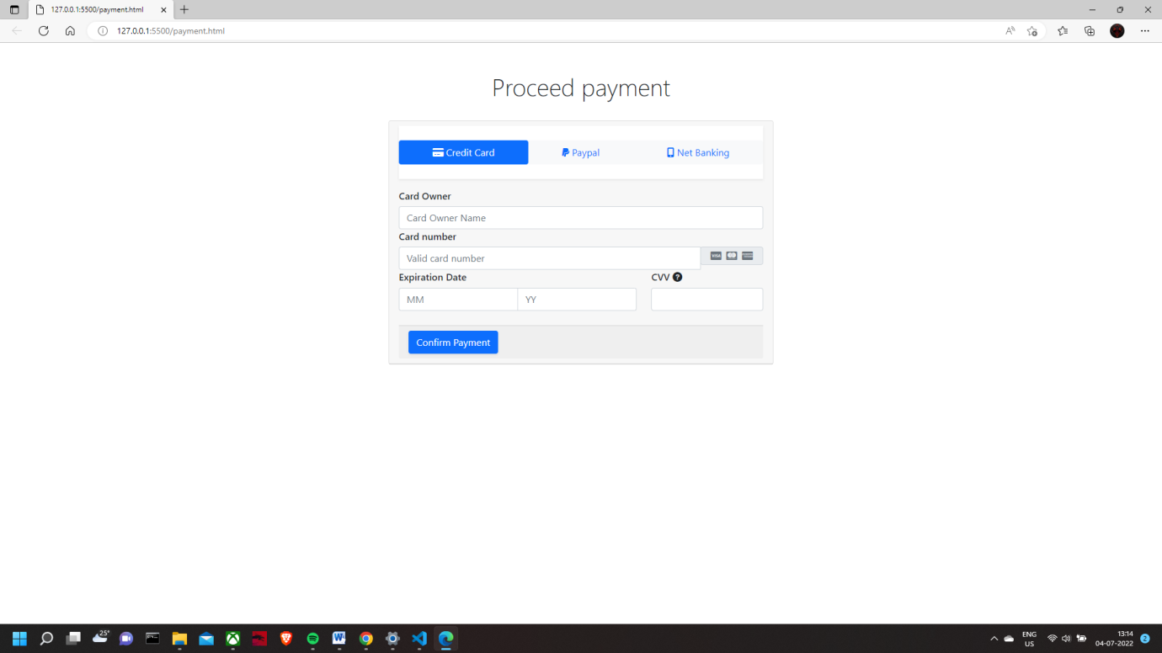

This payment gateway is just a demo as you have to go to bank and ask for someway to add official gateway but it is only given to highest referential org like amazon, gpay etc.. small vendors have to attach them with their gateways

**18. FUTURE SCOPE AND ENHANCEMENTS**

1. There will be further more changes done to the website as per user demands.
2. Various new sections will be introduced.
3. More images will be done and made separate sections for it.
4. Database will be highly collaborated and effective.
5. Website will be updated in a particular instance of time.
6. People will be able to add their photos and upload them to user view.
7. Timely notifications will be transferred.
8. Spam mails won’t exist.
9. New offers will be given on time to time basis.

**19. SYSTEM TESTING**

**System Testing** is a level of testing that validates the complete and fully integrated software product. The purpose of a system test is to evaluate the end-to-end system specifications. Usually, the software is only one element of a larger computer-based system.

The goal of integration testing is to detect any irregularity between the units that are integrated together. System testing detects defects within both the integrated units and the whole system. The result of system testing is the observed behavior of a component or a system when it is tested. System Testing is carried out on the whole system in the context of either system requirement specifications or functional requirement specifications or in the context of both. System testing tests the design and behavior of the system and also the expectations of the customer. It is performed to test the system beyond the bounds mentioned in the software requirements specification (SRS).

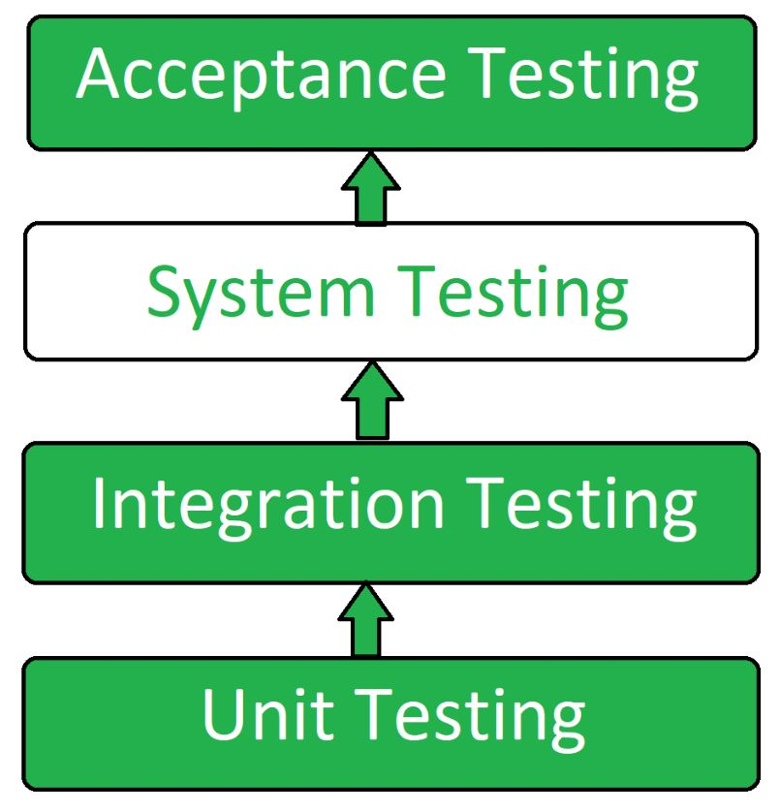

**System Testing Process: System Testing is performed in the following steps:**

**Test Environment Setup**: Create test environment for the better quality test.

**Create Test Case:** Generate test case for the testing process.

**Create Test Data:** Create the data that is to be tested.

**Execute Test Case**: After the creation of the test case and the test data, test cases are executed one by one.

**Defect Reports:** Defects in the system are detected and executed and then solved.

**Regression Testing**: It is carried out to test the side effects of the testing process.

Log Defects: Defects are fixed in this step.

Retest: If the test is not successful then again test is performed.

**Types of System Testing:**

**Performance Testing**: Performance testing is a type of software testing that is carried out to test the speed, scalability, stability and reliability of the website.

**Load Testing**: Load Testing is a type of testing which is carried out to determine the behavior of a system or software product under extreme load.

**Stress Testing**: Stress testing is a type of software testing performed to check the robustness of the system under the varying loads.

**Scalability Testing**: Scalability Testing is a type of software testing which is carried out to check the performance of a software application or system in terms of its capability to scale up or scale down the number of user request load.

**20. DATABASE AND CONNECTIVITY**

The database connectivity is the main and most important step to keep the record of what all reservations are made and what all changes are to be done.

**How to create database**

A database is a structured set of organized data. In the IT field, [**database management systems (DBMS)**](https://www.hostinger.in/tutorials/dbms)refer to software that interacts with a user, data, and retrieve and store data.

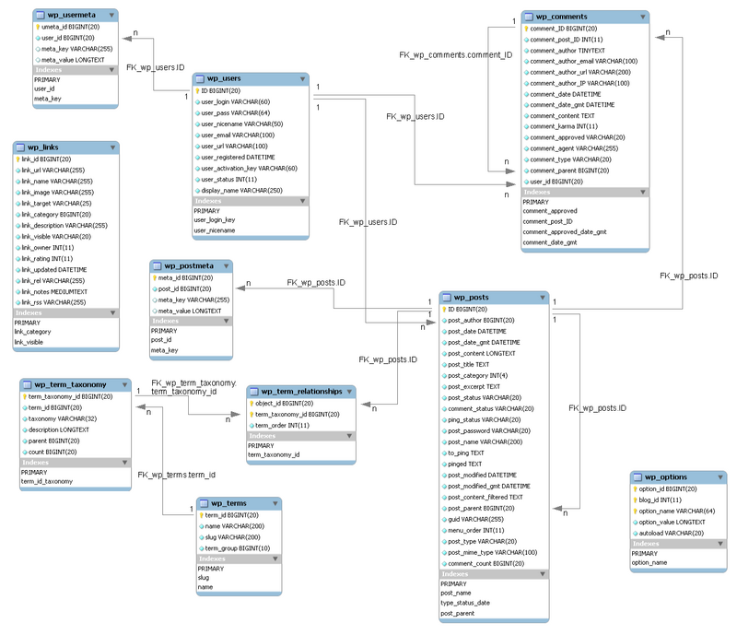

Create a MySQL database

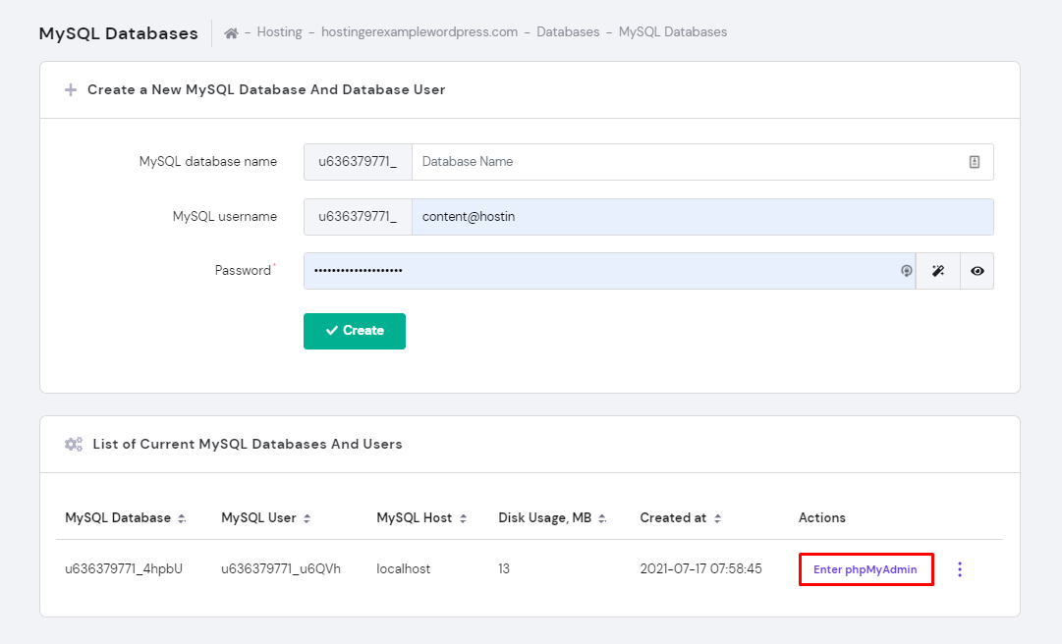

Hotel reservation

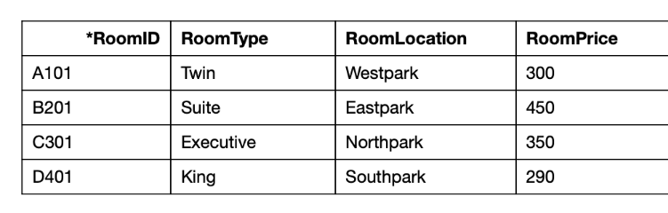

We can clearly see what is the id of the people and their room booking from date to time

Bus booking:-

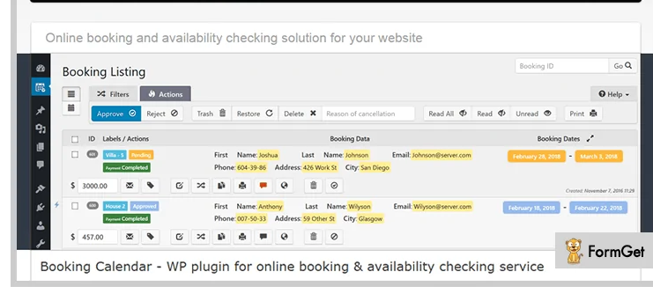

Tour and travel

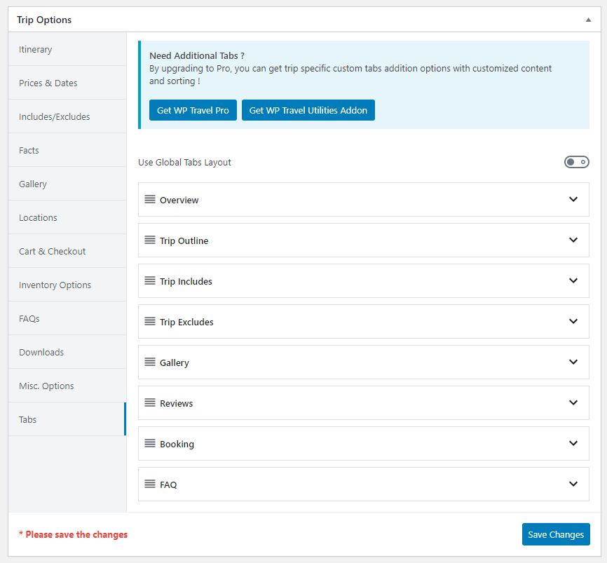

**21. CONCLUSION**

The project as a whole describes the scope and viability of the travel indusry and mainly of the financial, technical and its market potential. The project guarantee sufficient fund to repay the loan and also give a good return on capital investment. When analyzing the social- economic impact, this project is able to generate an employment of 5 and above.

It will cater the demand in travel forum and thus helps the other business entities to increase the production and service which provide service and support to this industry.

Thus more cyclic employment and livelihood generation. So in all ways, we can conclude the project is technically and socially viable and commercially sound too. More growth of the organization means more growth of the people around it.

**22. BIBLIOGRAPHY**

1. Get bootstrap5 for designing purpose.
2. W3schools for learning.
3. Shopify for new ideas and creations.
4. GeekforGeeks for content and code related ideas.
5. Fontawesome for various fonts and icons.
6. VS-Code for live server and designing.
7. MS-WORD for documentation.
8. UDEMY for javascript and jquery.
9. UPLASH and BURST for non-copyright assets.
10. VS-CODE by ALESSANDRO DEL SOLE